



**Module Code & Title**

CS6P05 Final Year Project MAD

Food Share - Android App

Artefact – Designing

**Student Details**

Name: Sita Ram Thing

London Met Id: 22015892

College Id: NP01MA4S220003

Islington College, Kathmandu

24 April 2024

Contents

1. Research and practice 5

2. Use Case 22

3. Sequence Diagram 23

4. Context Diagram 29

5. Activity Diagram 31

3.6.3. View History Activity 36

6. Wireframes 38

7. ERD 60

8. System Architecture Diagram 61

9. Class Diagram 62

10. DFD's level 2 63

List of Figure

Figure 1: Luci chart tools context 5

Figure 2: pratic to DDF diagram 8

Figure 3: DFD Develop the volunteer size 9

Figure 4: Context Diagram Develop 10

Figure 5: ER-Diagram pratic 11

Figure 6: Entity relationship diagram 12

Figure 7: Use case diagram design 13

Figure 8: Sequence diagram pyritic 14

Figure 9: Varaible collection for ERD development 15

Figure 10: Wireframe design piratic 16

Figure 11: Wireframe design 17

Figure 12: ER-Diagram connection. 18

Figure 13: Attribute collection for ERD 19

Figure 14: Context diagram design 20

Figure 15: DFD level 2 21

Figure 16: Use-case Diagram 22

Figure 14: View profile sequence diagram 24

Figure 15: View the history sequence diagram 25

Figure 16: Food Post for donation sequence diagram 26

Figure 17: Donation rating sequence diagram 27

Figure 18: Complaint with admin sequence diagram 28

Figure 17: Context diagram 29

Figure 18: DFD Develop 30

Figure 19: Take the membership activity diagram 31

Figure 20: Food donation system activity diagram 32

Figure 21: Login system activity diagram 33

Figure 22: Register system activity diagram 34

Figure 23: Logout system activity diagram 35

Figure 24: View the history system activity diagram. 36

Figure 25: Rating donation system activity diagram 36

Figure 26: Complaint with admin system activity diagram 37

Figure 27: Walkthrough screen mobile UI 38

Figure 28: Welcome screen mobile UI 39

Figure 29: Login screen mobile UI 40

Figure 30: Register screen mobile UI 41

Figure 31: Splash screen mobile UI 42

Figure 32: Register response message mobile UI 43

Figure 33: Donor Profile screen mobile UI 44

Figure 34: Donor Setting screen mobile UI 45

Figure 35: Volunteer Setting screen UI 46

Figure 36: NGO Users screen UI 47

Figure 37: NGO Profile screen UI 48

Figure 38: Forgot password screen mobile UI 49

Figure 39: Donor Home screen mobile UI 50

Figure 40: Donor History screen mobile UI 51

Figure 41: Donor Post/Donation screen mobile UI 52

Figure 42: Volunteer Home screen UI 53

Figure 43: Volunteer Pending screen UI. 54

Figure 44: Volunteer History Screen 55

Figure 45: NGO Home screen UI 56

Figure 46: NGO History screen UI 57

Figure 47: Admin login page web UI 58

Figure 48: Admin forgot password UI. 58

Figure 49: Admin dashboard UI 59

Figure 50: ER-Diagram 60

Figure 51: System Architecture Diagram 61

Figure 52: Class diagram of food donation application 62

Figure 53: Take membership details DFD Level-2 63

Figure 54: Food donation DFD Level-2 64

Figure 55: View Donation History DFD Level-2 65

Figure 56: Donation rating DFD Level-2 66

Figure 57: Complaint with admin DFD Level-2 67

Figure 58: Register details DFD Level-2 68

Figure 59: Login details DFD Level-2 69

# Research and practice

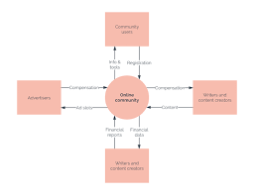

Figure 1: Luci chart tools context

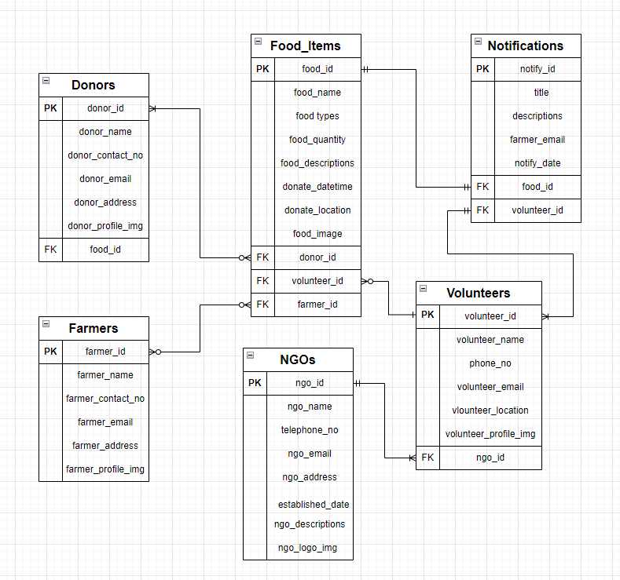

Figure 2: ER-Diagram

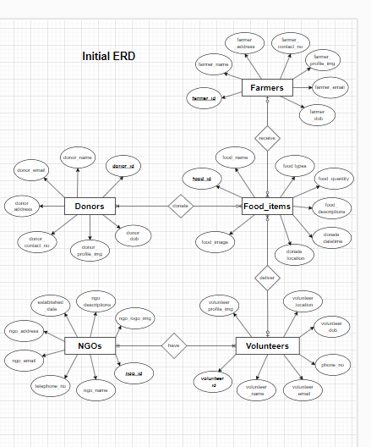

Figure 3: Initial ERD

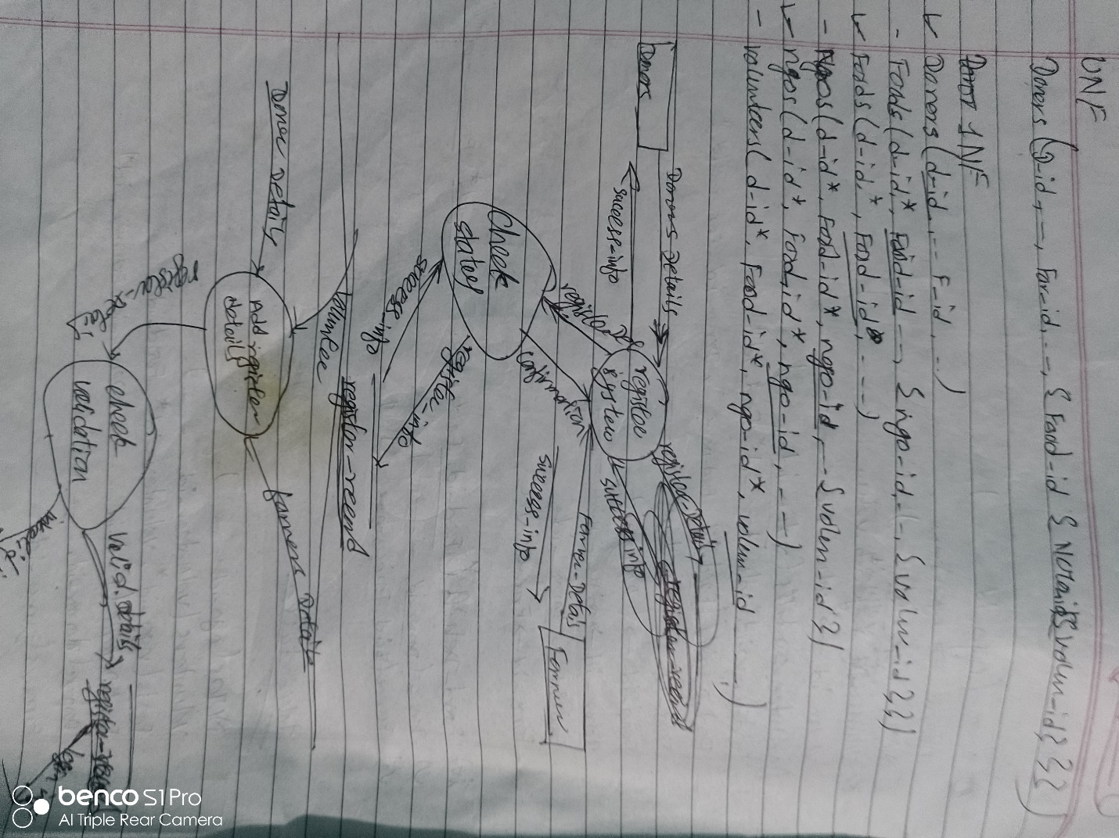

Figure 4: pratic to DDF diagram

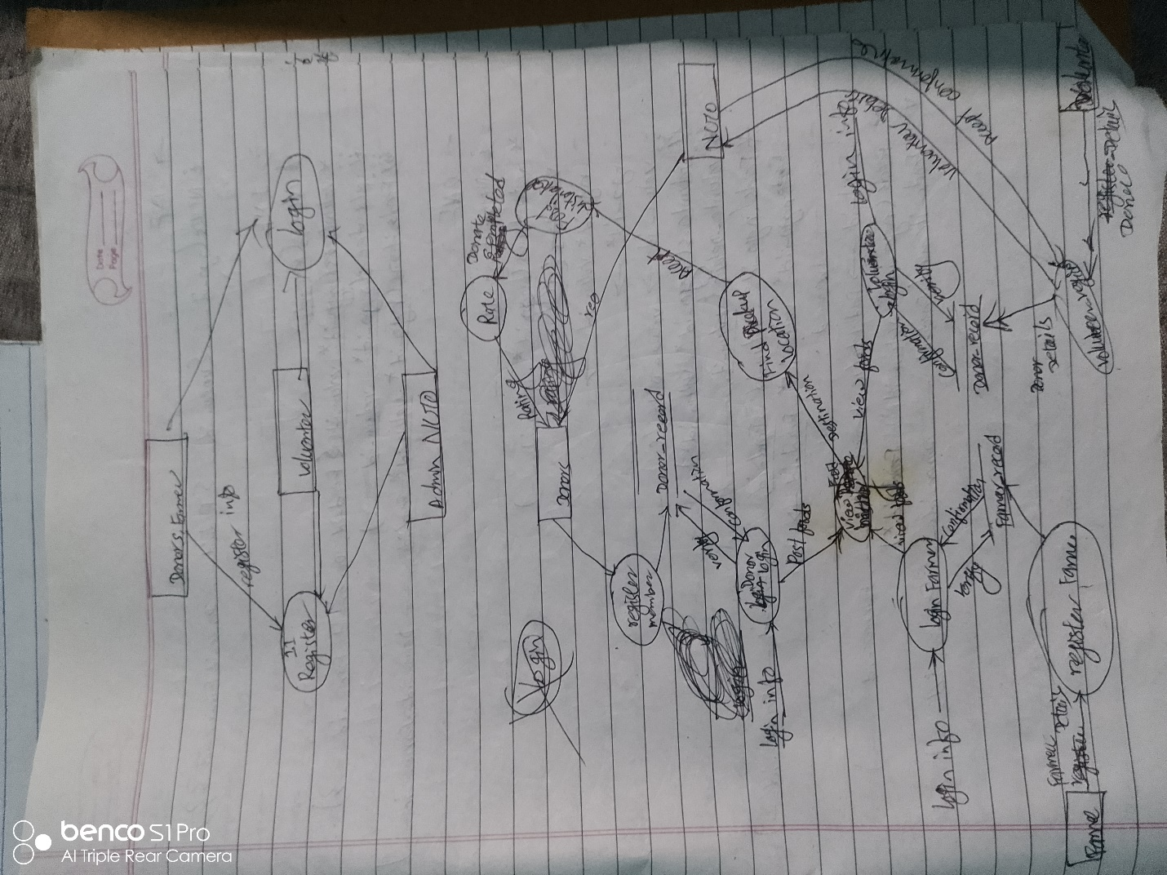

Figure 5: DFD Develop the volunteer size

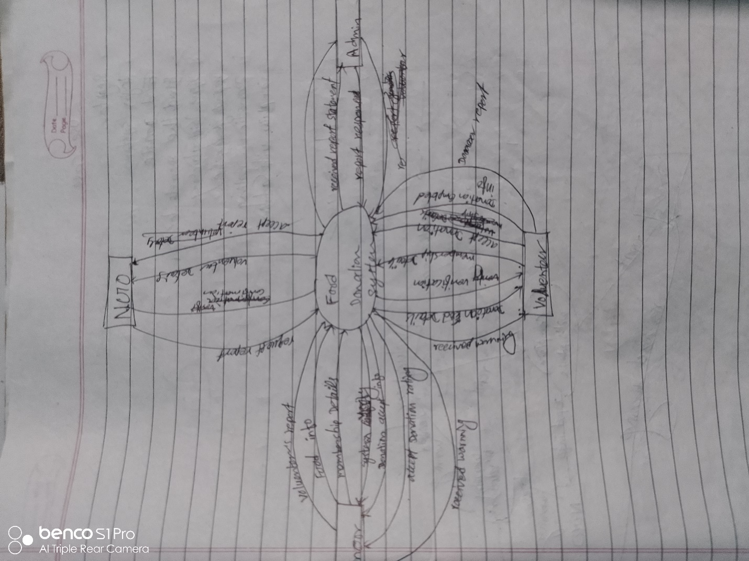

Figure 6: Context Diagram develop

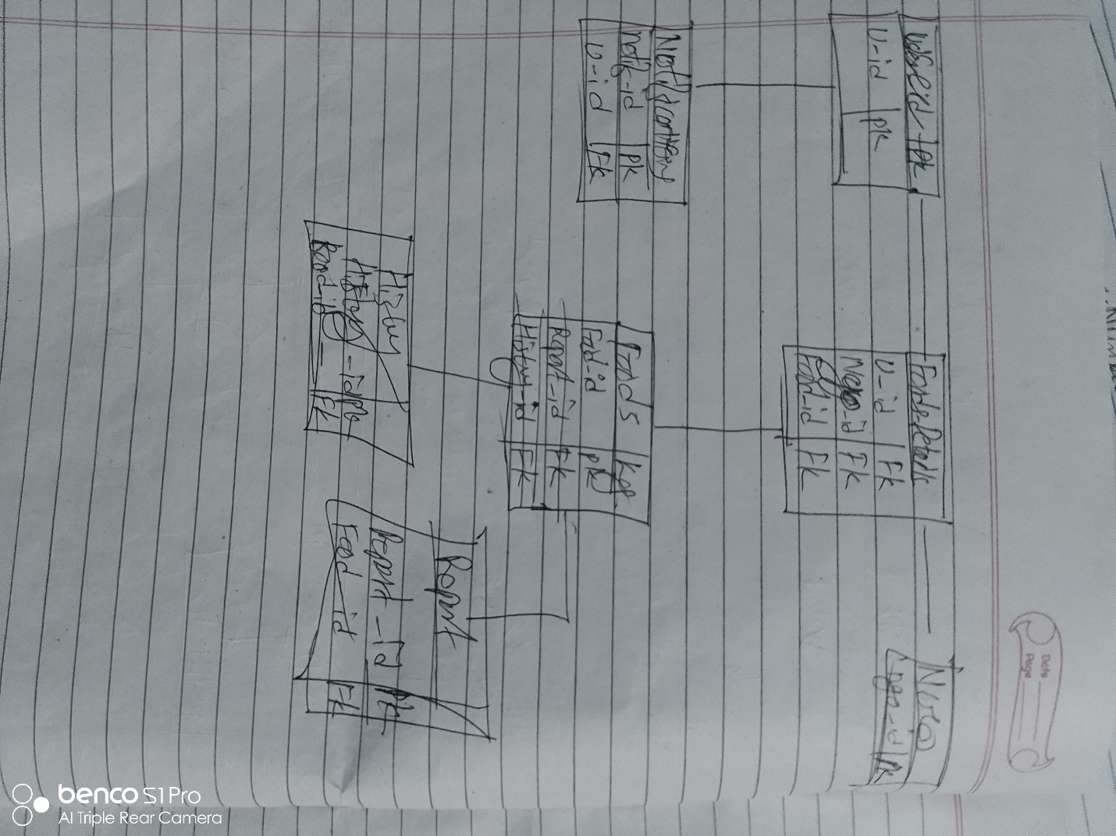

Figure 7: ER-Diagram pratic

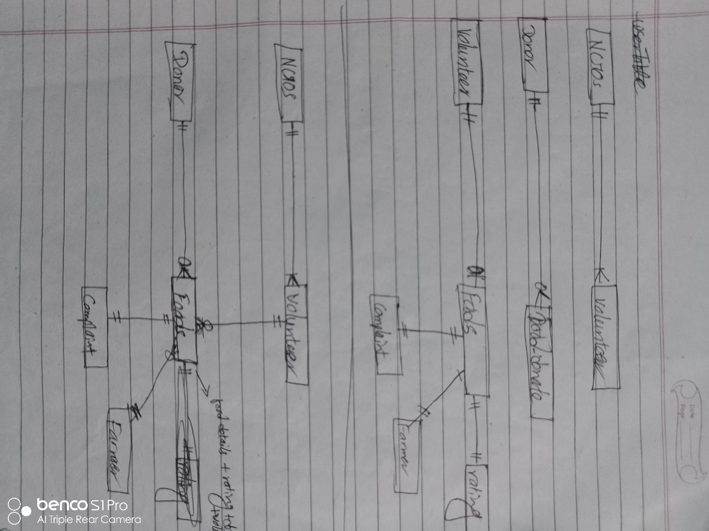

Figure 8: Entity relationship diagram

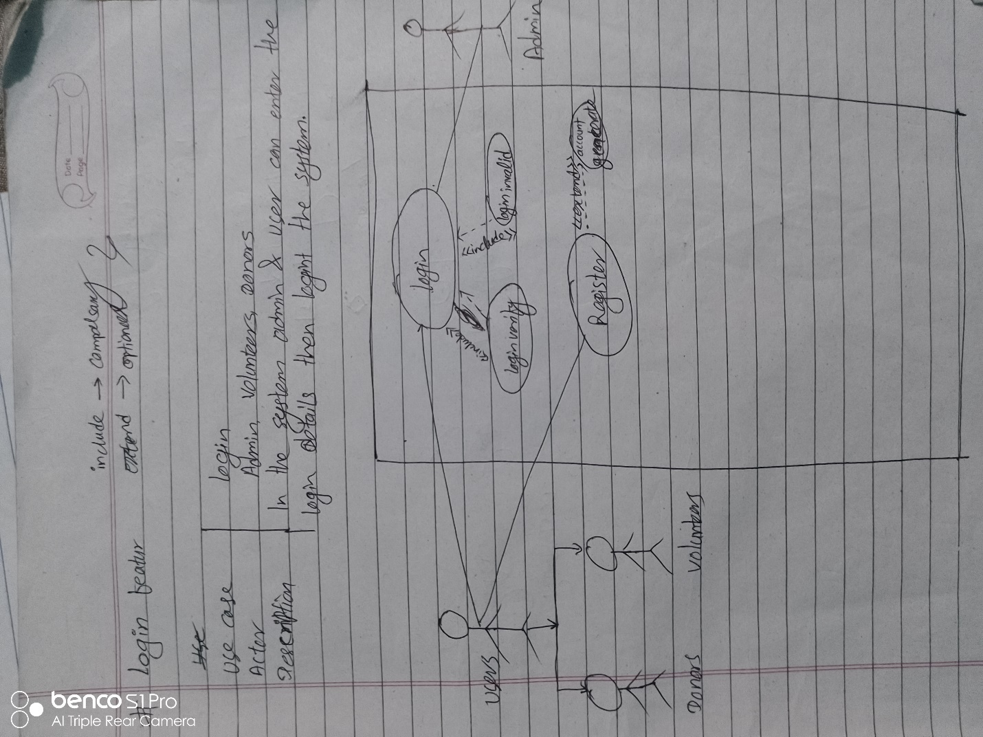

Figure 9: Use case diagram design

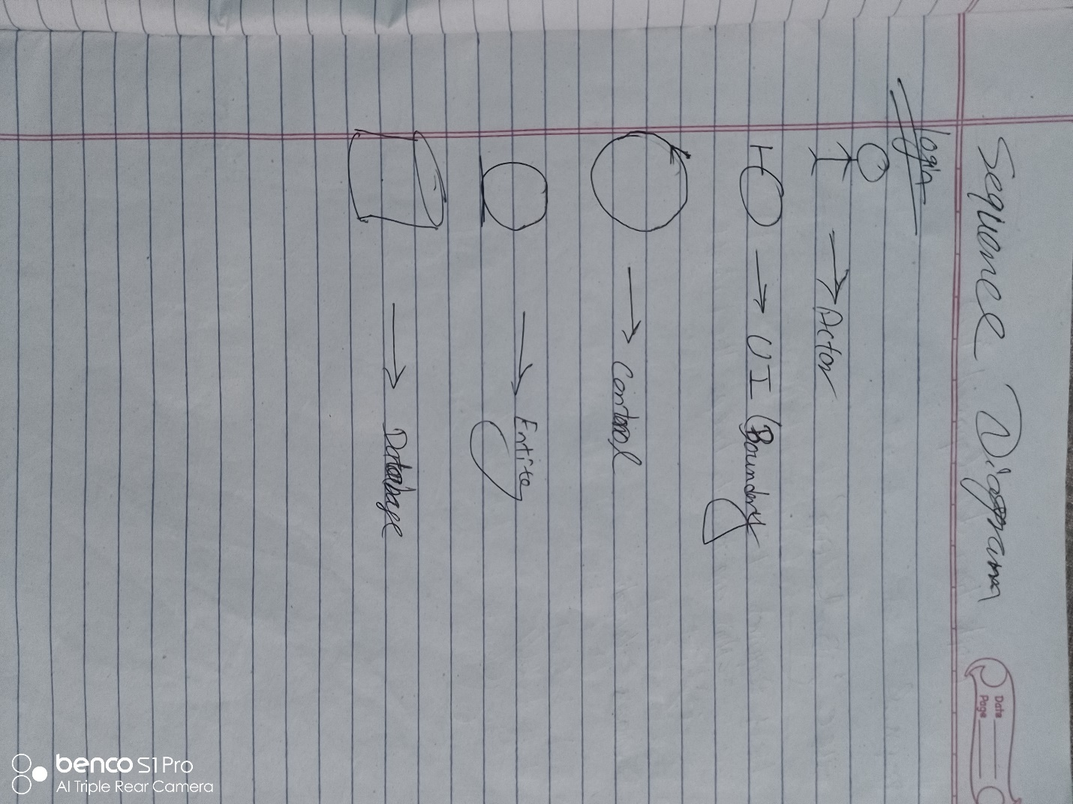

Figure 10: Sequence diagram pyritic

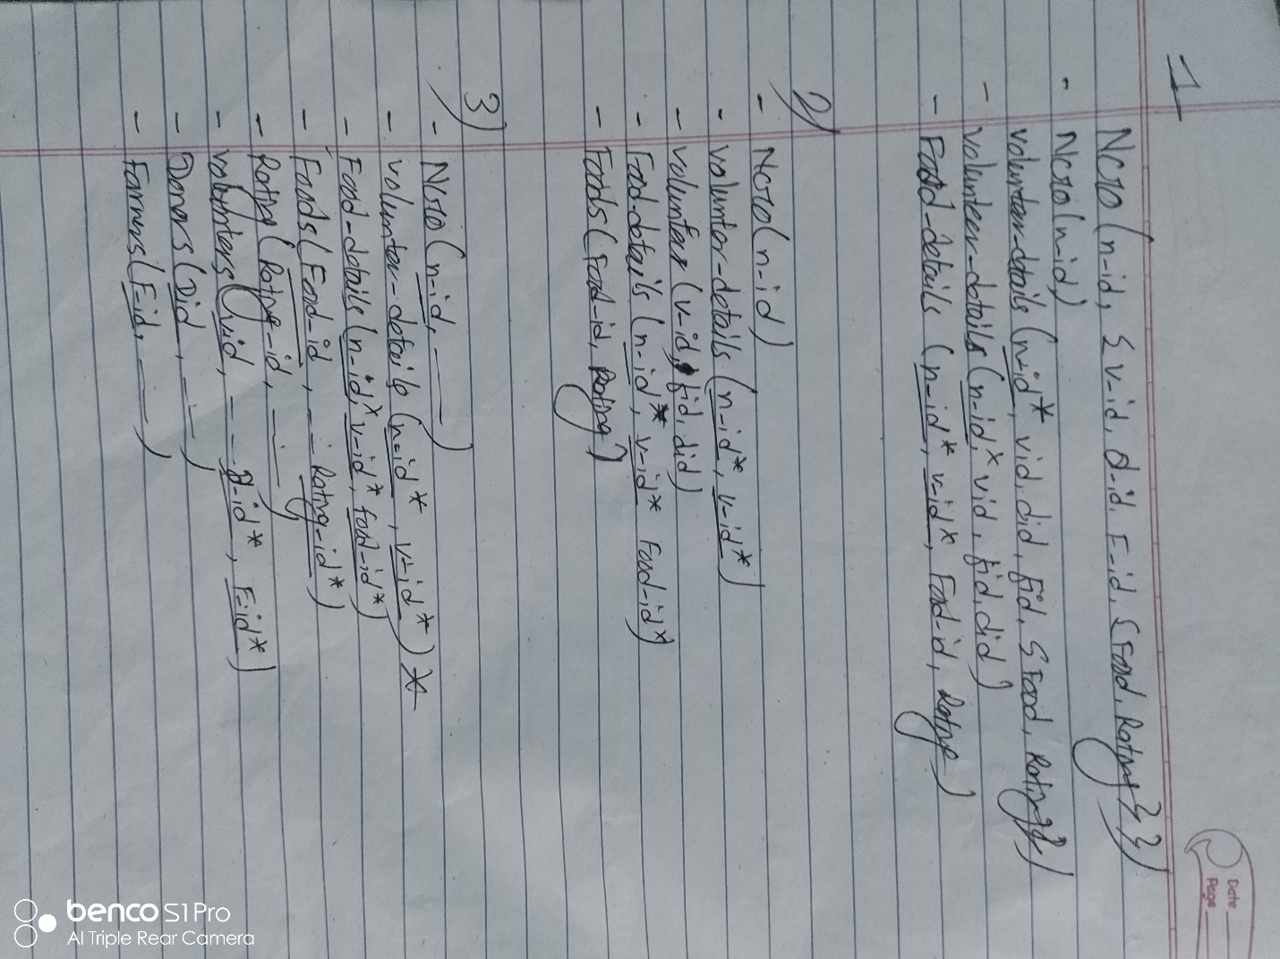

Figure 11: Varaible collection for ERD develop

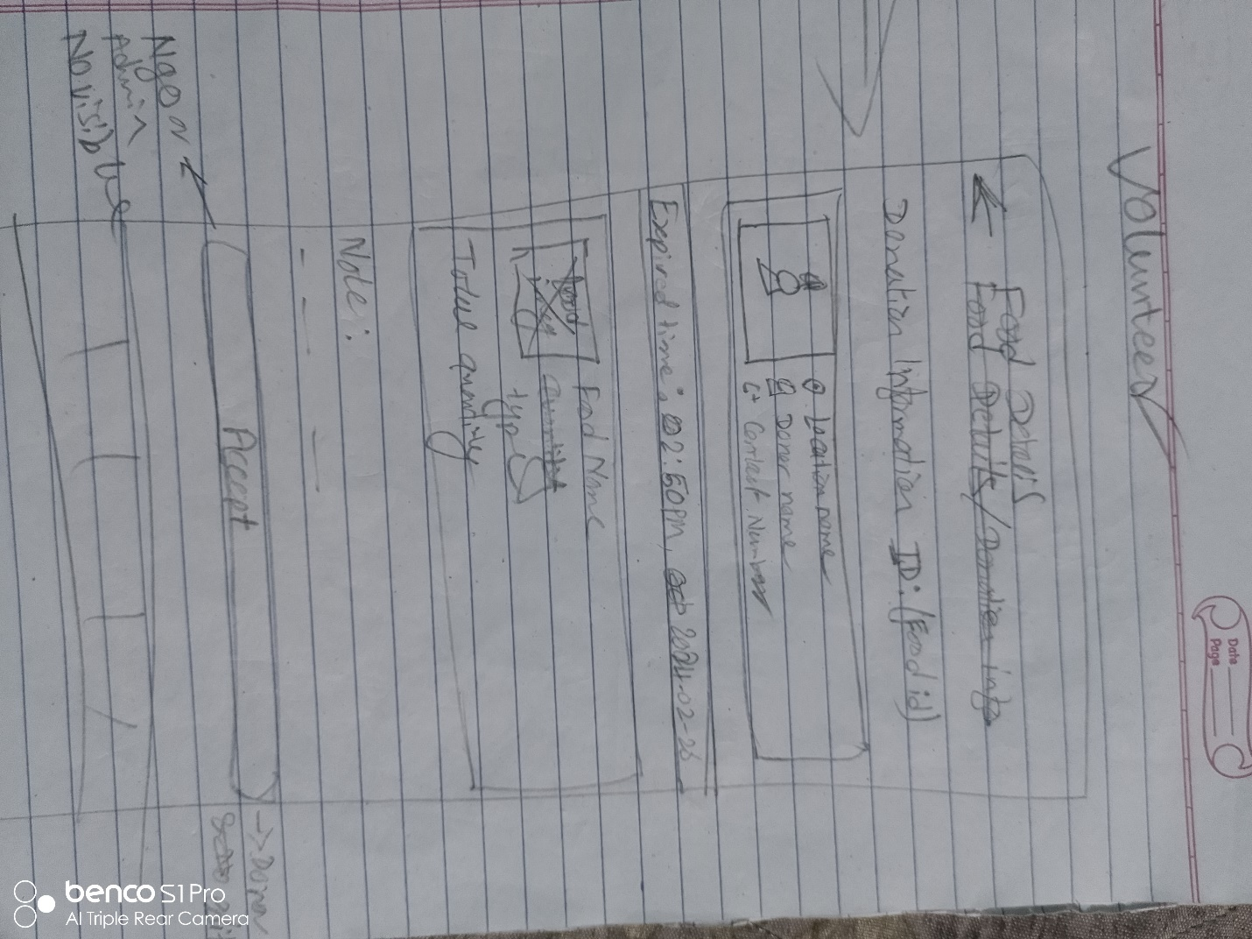

Figure 12: Wireframe design piratic

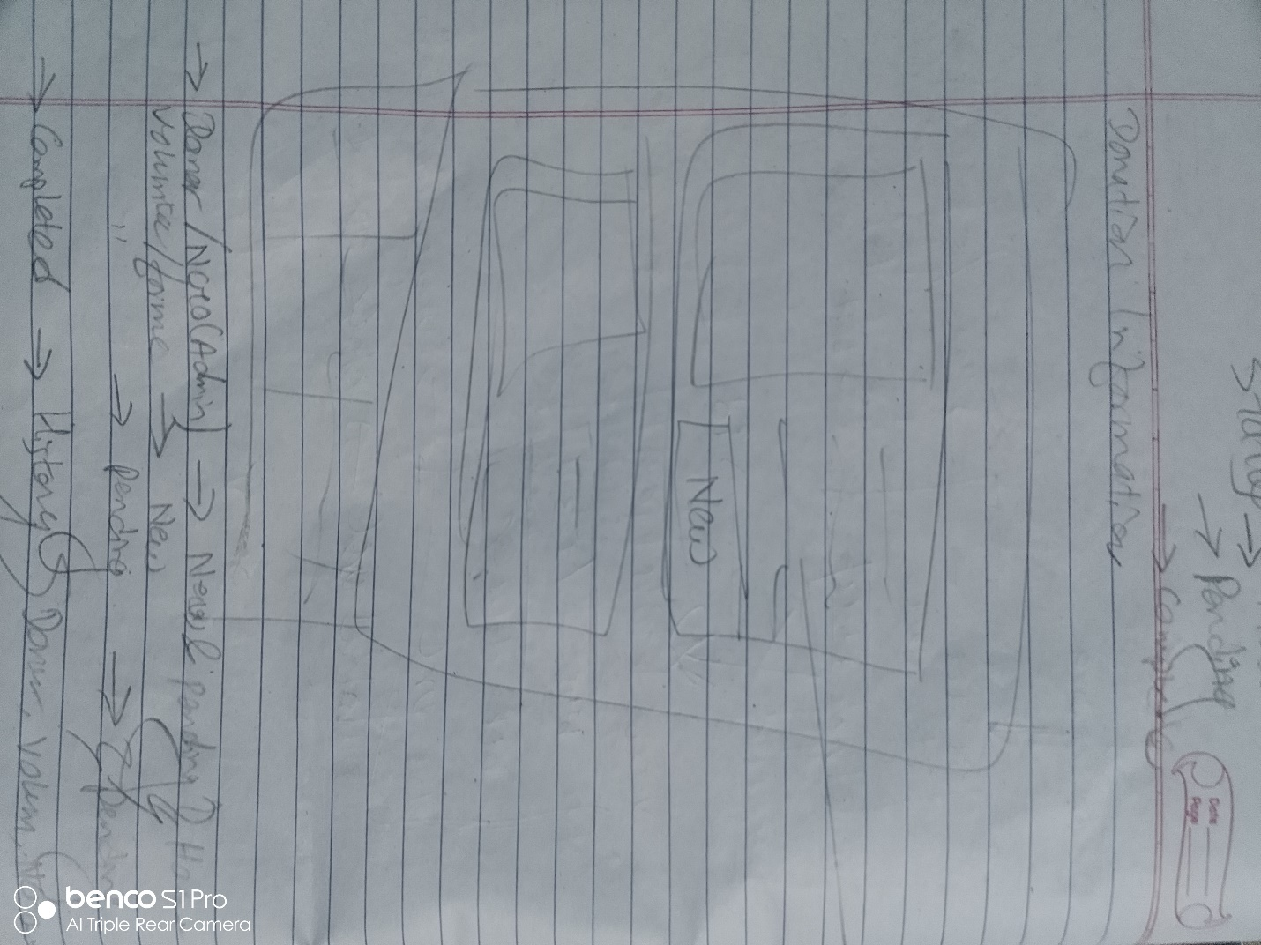

Figure 13: Wireframe design

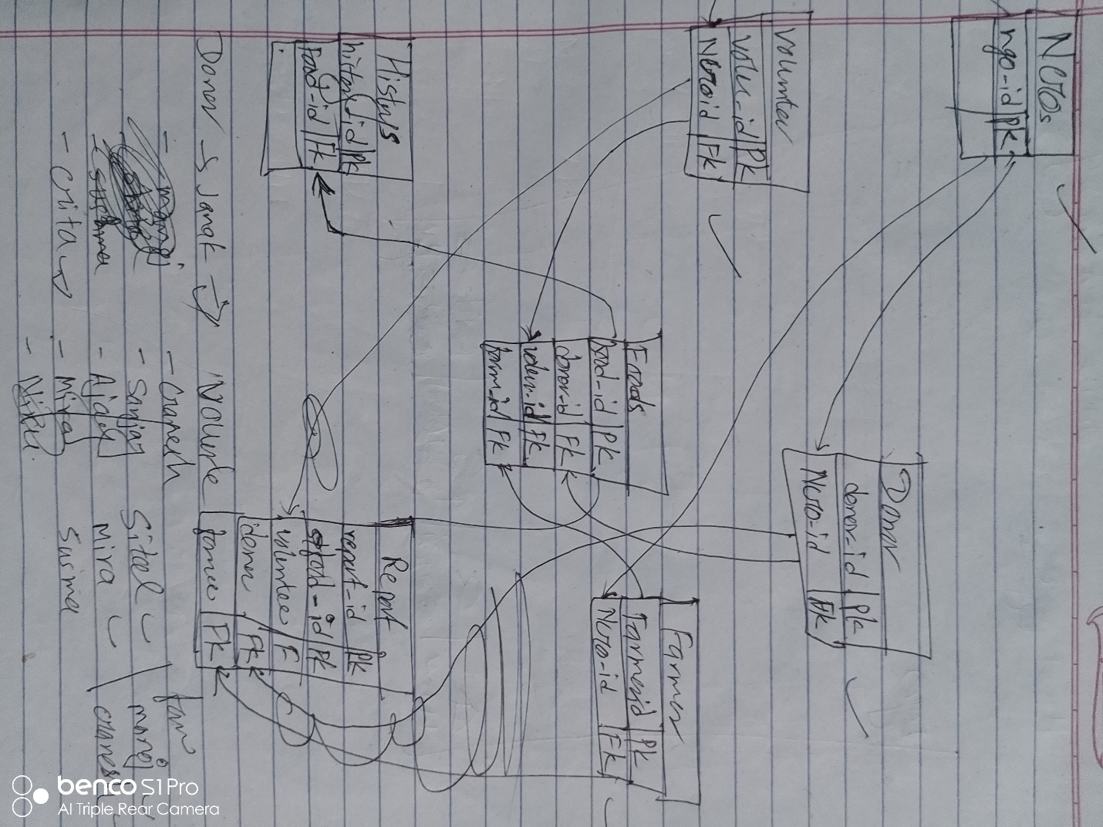

Figure 14: ER-Diagram connection.

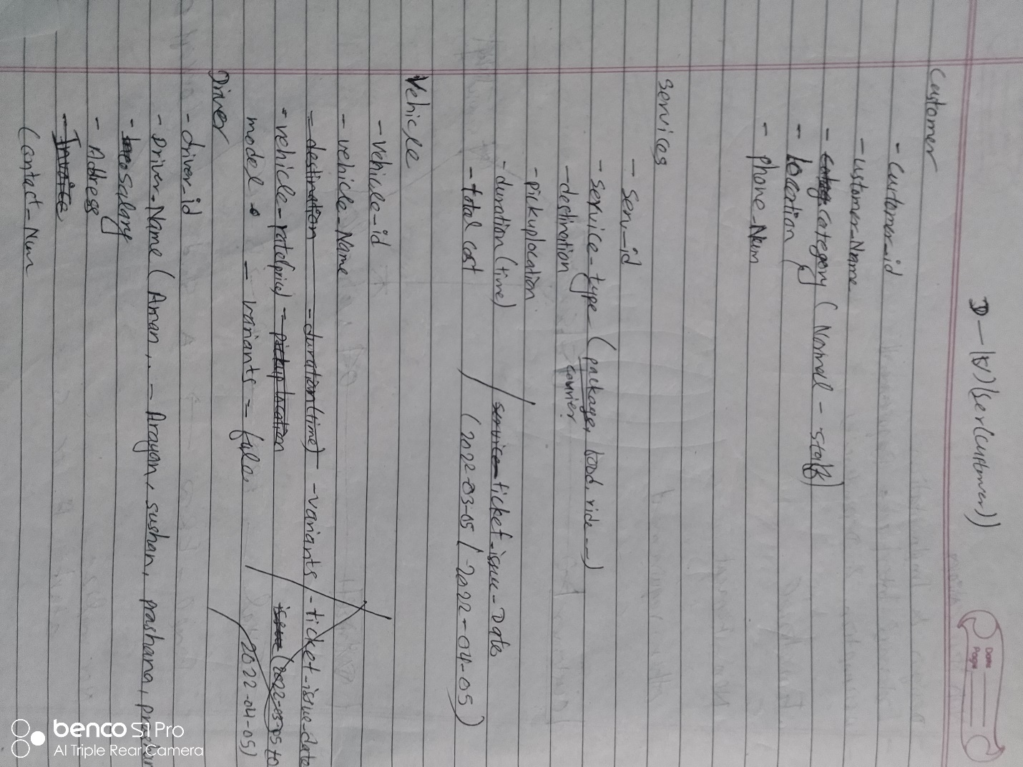

Figure 15: Attribute collection for ERD

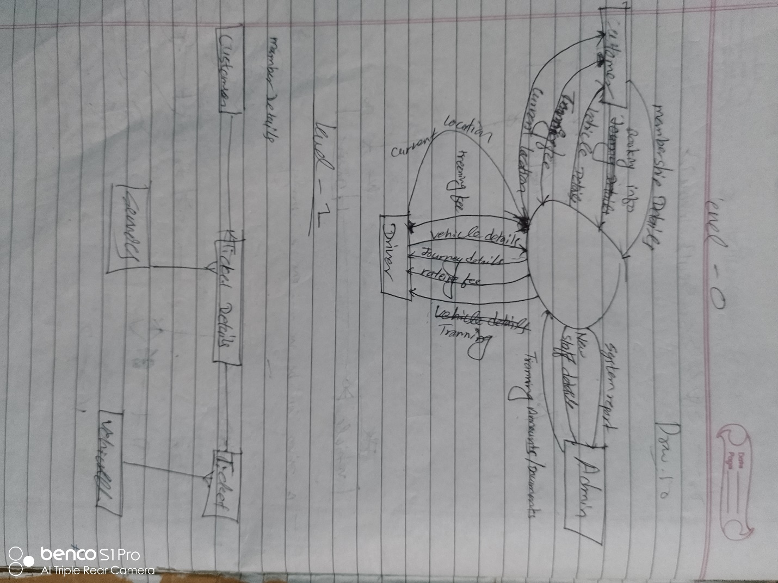

Figure 16: Context diagram design

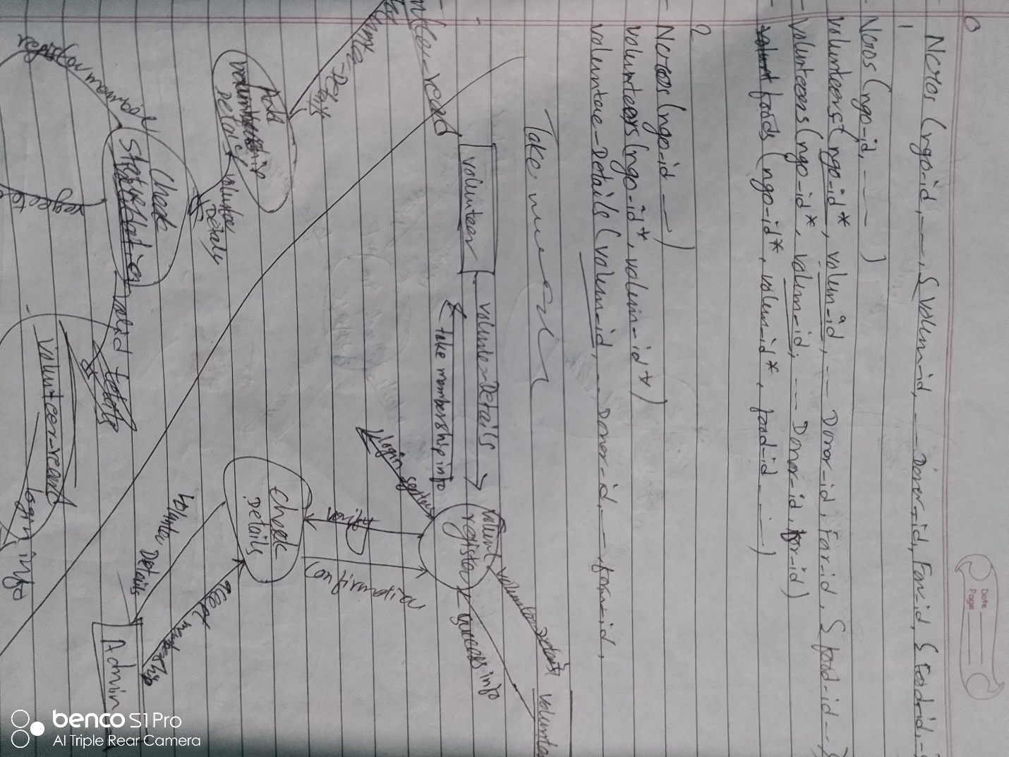

Figure 17: DFD level 2

# Use Case

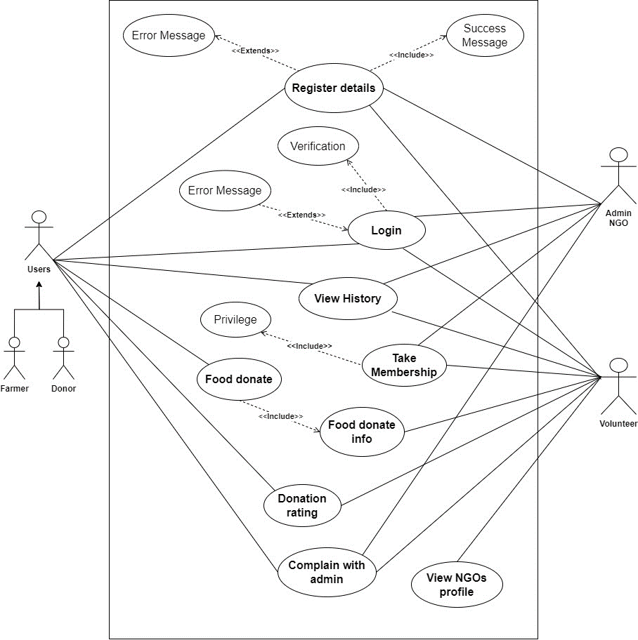

Figure 18: Use-Case diagram

# Sequence Diagram

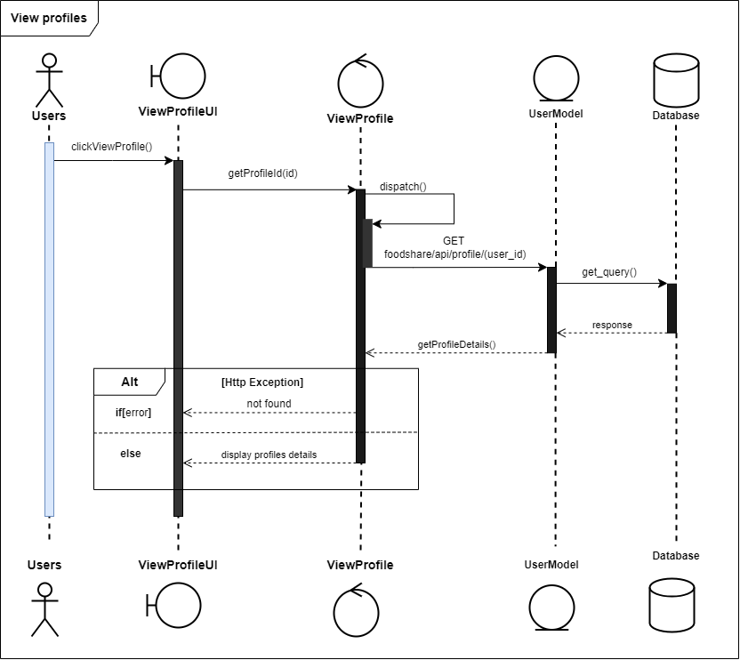

Figure 19: View profile sequence diagram

3.3.2. View history sequence diagram

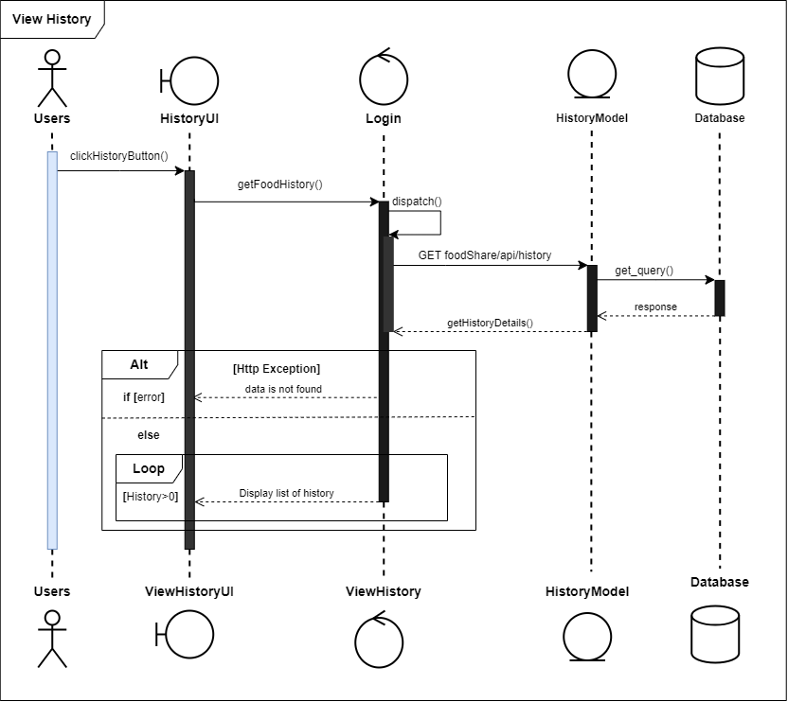

Figure 20: View the history sequence diagram

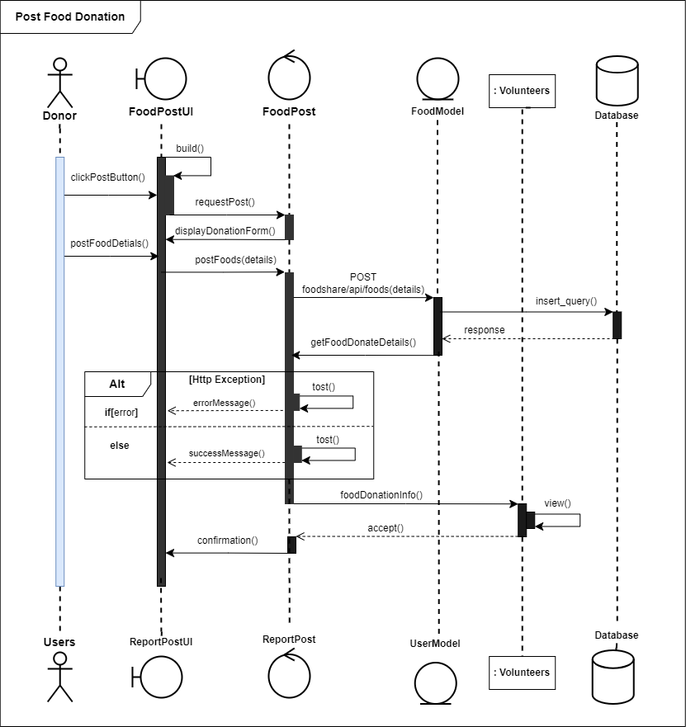

Figure 21: Food Post for donation sequence diagram

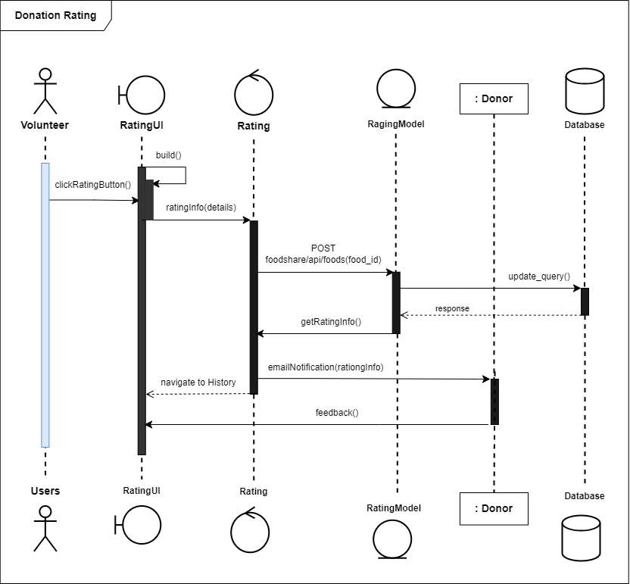

Figure 22: Donation rating sequence diagram

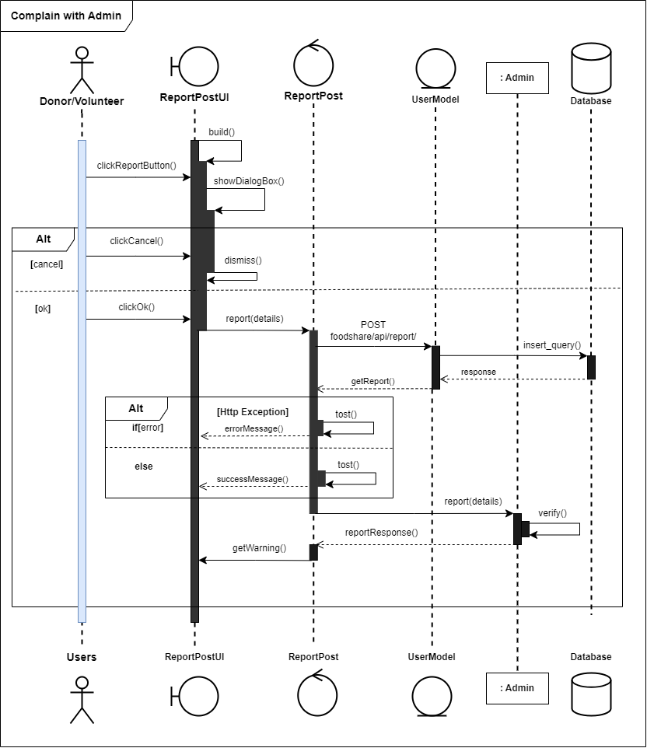

Figure 23: Complaint with admin sequence diagram

# Context Diagram

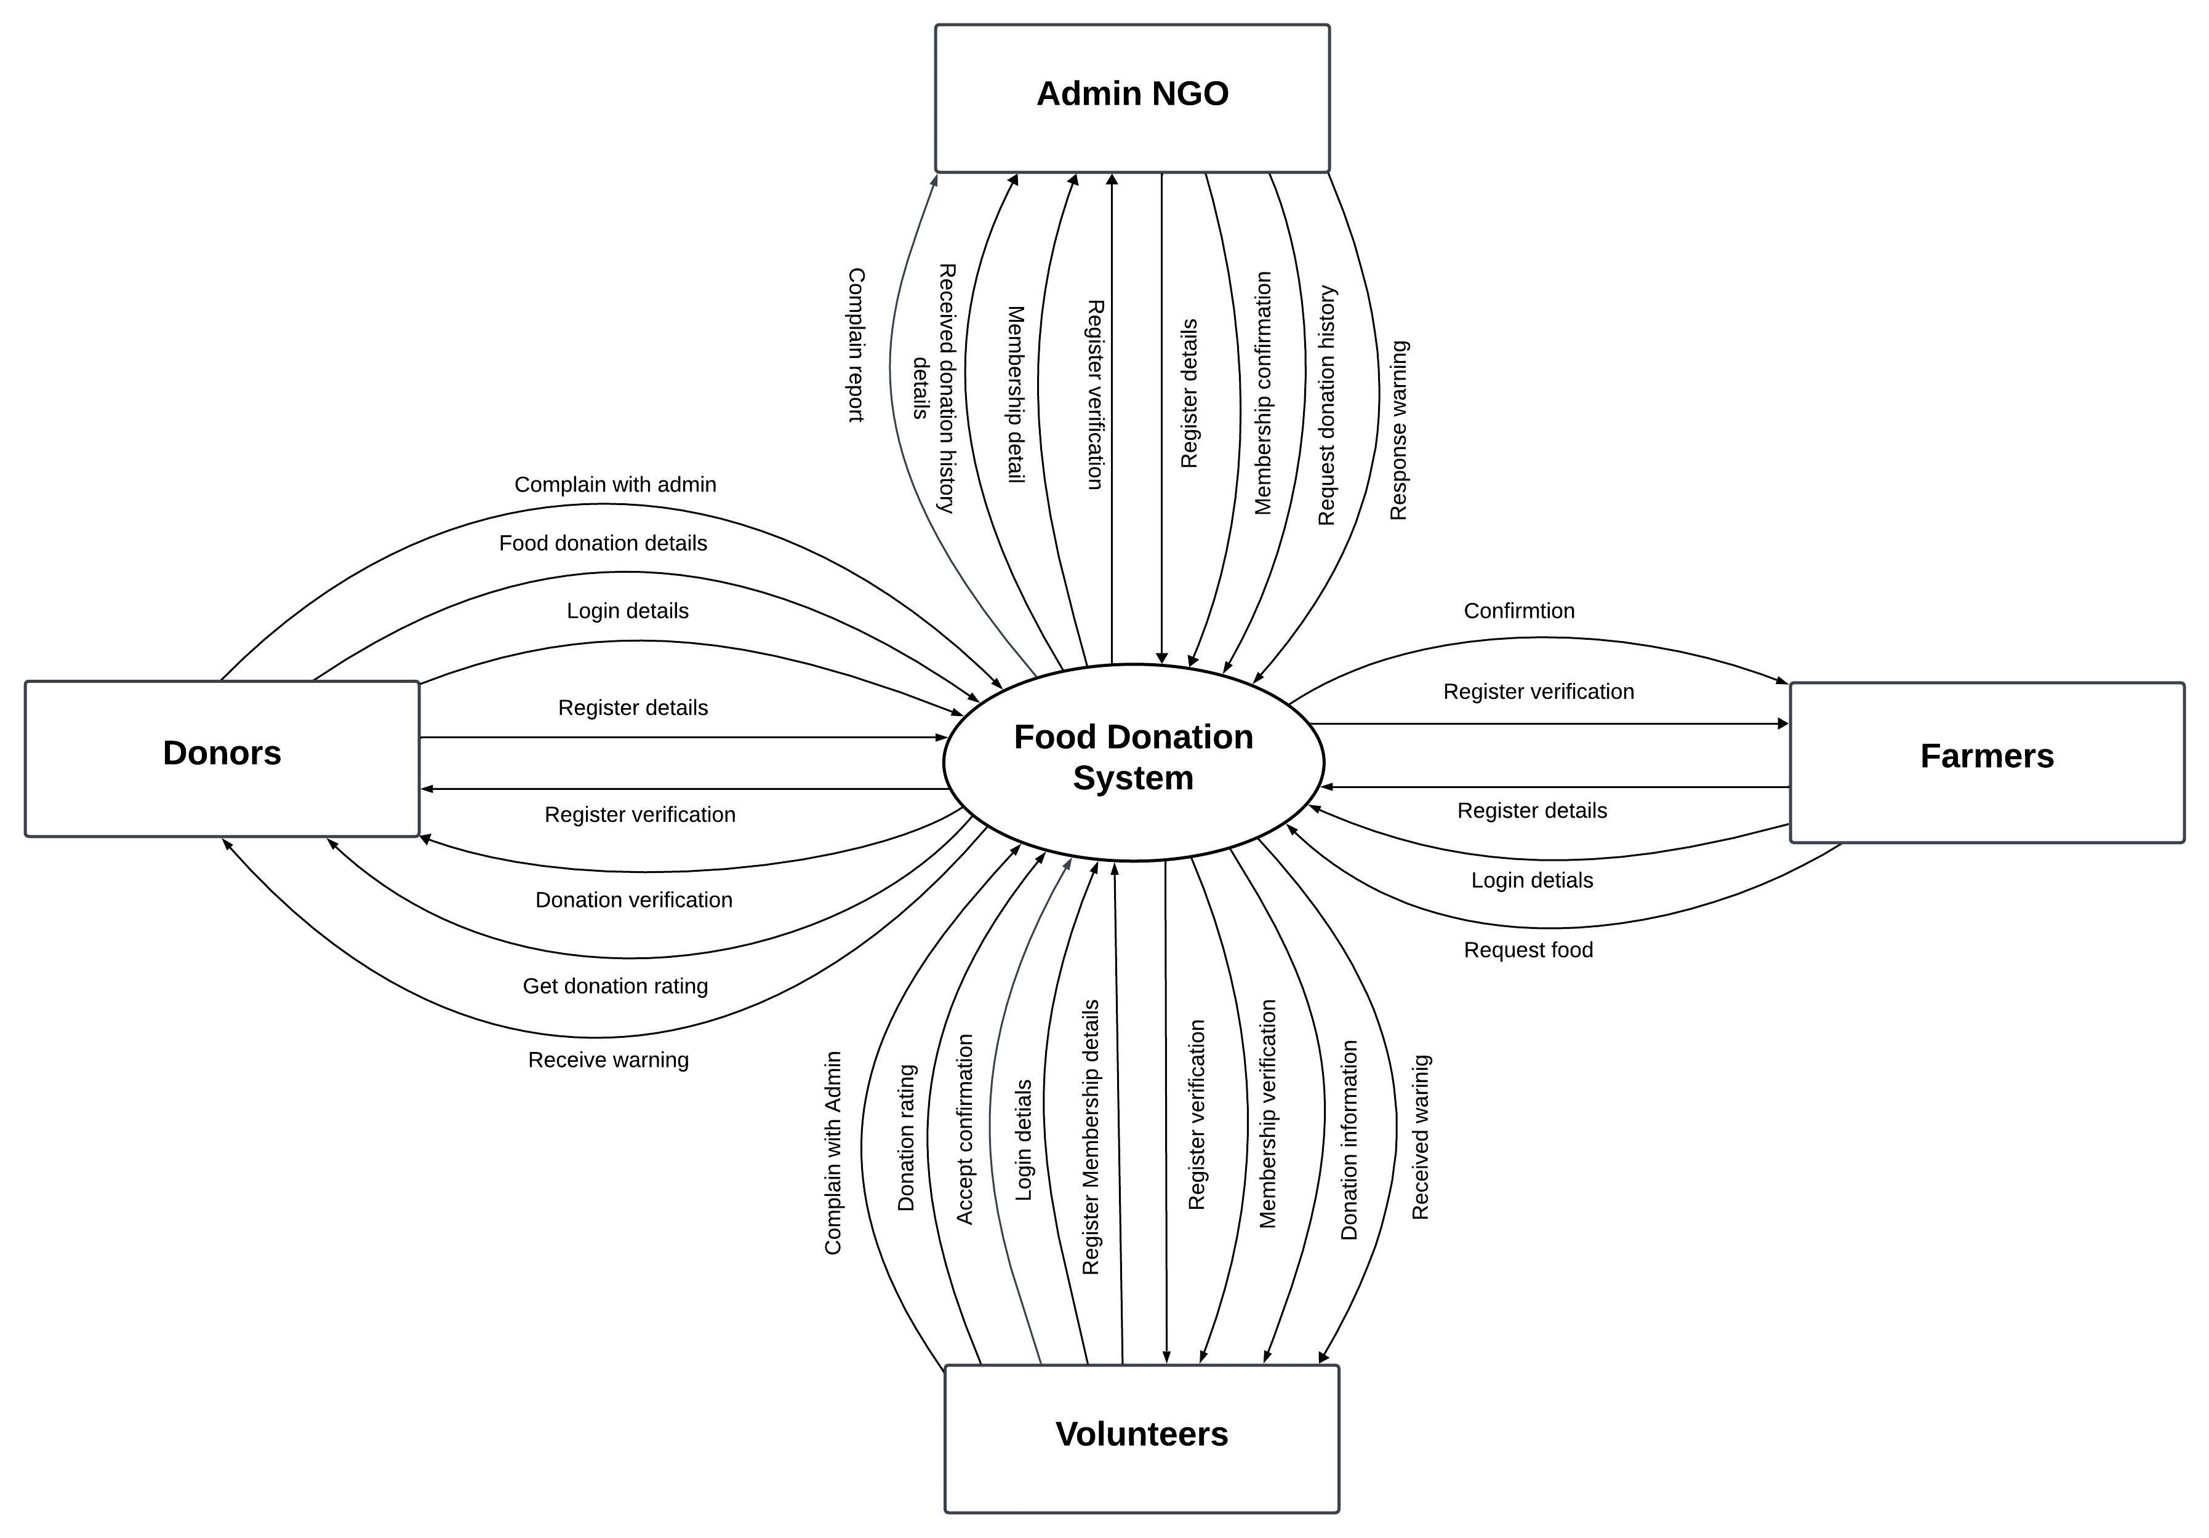

Figure 24: Context diagram

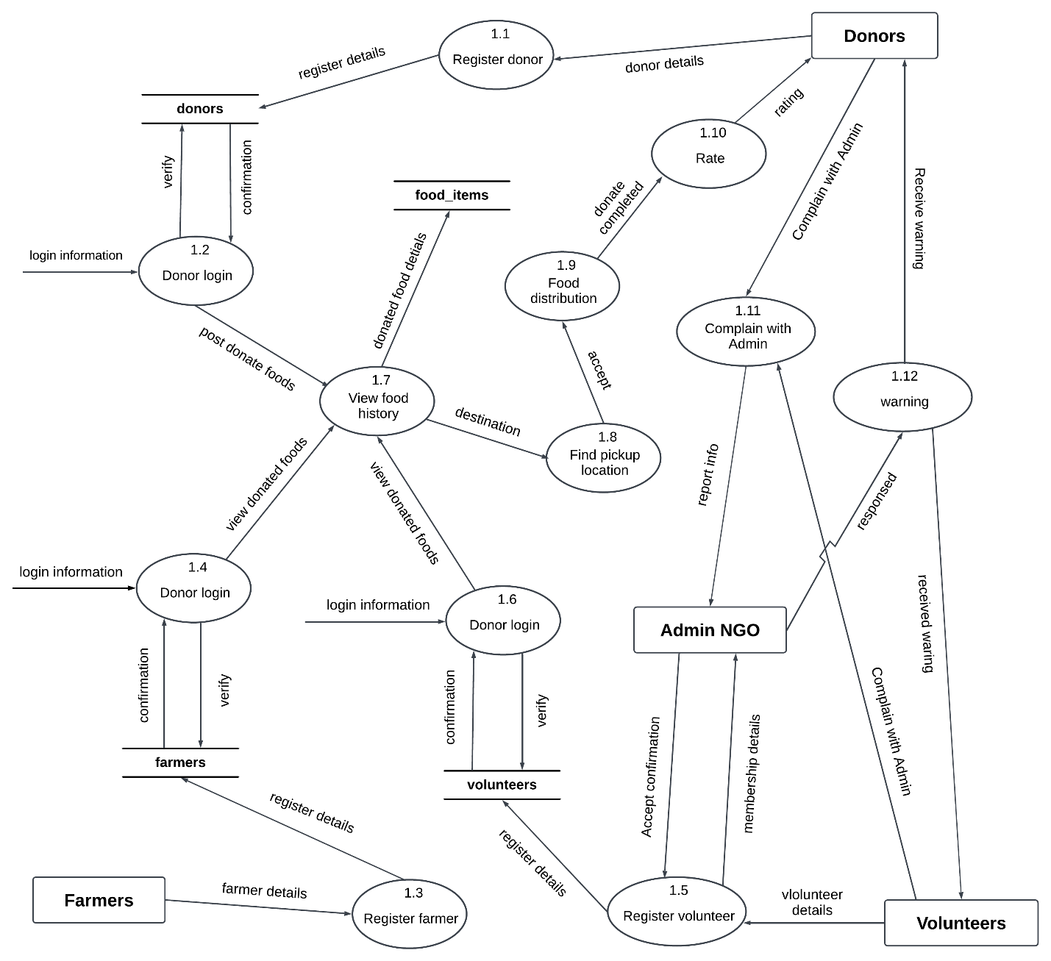

Figure 25: DFD Develop

# Activity Diagram

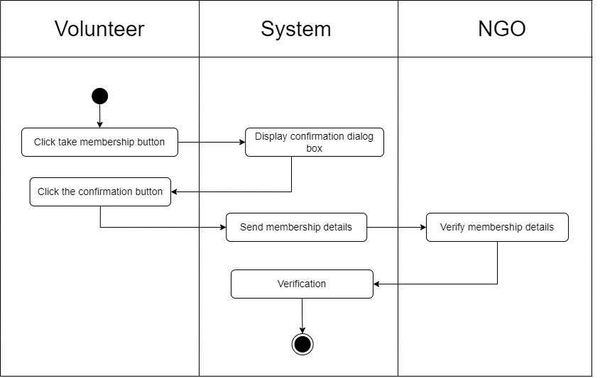

Figure 26: Take the membership activity diagram

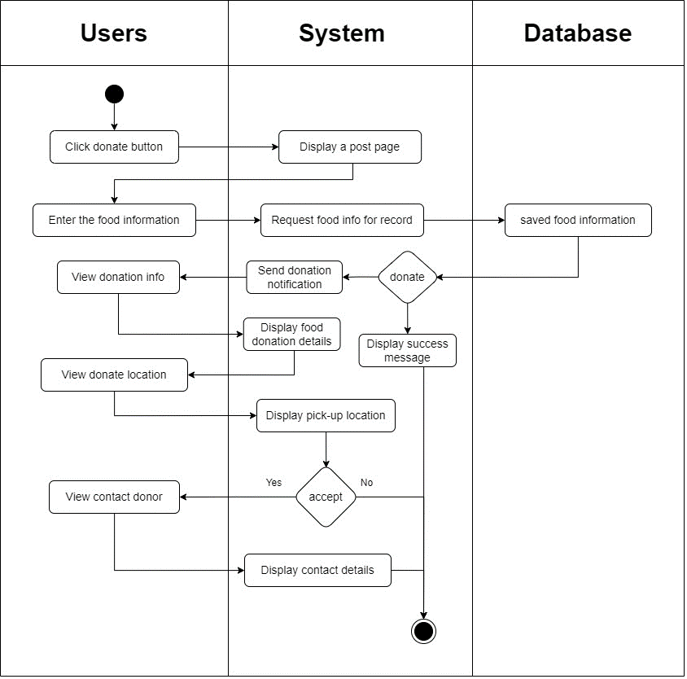

Figure 27: Food donation system activity diagram

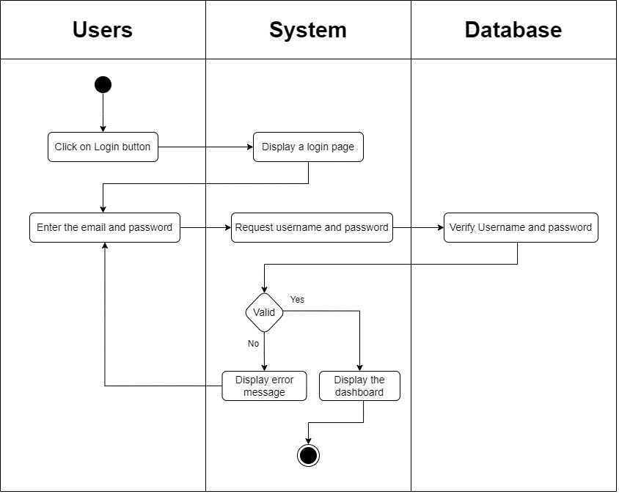

Figure 28: Login system activity diagram

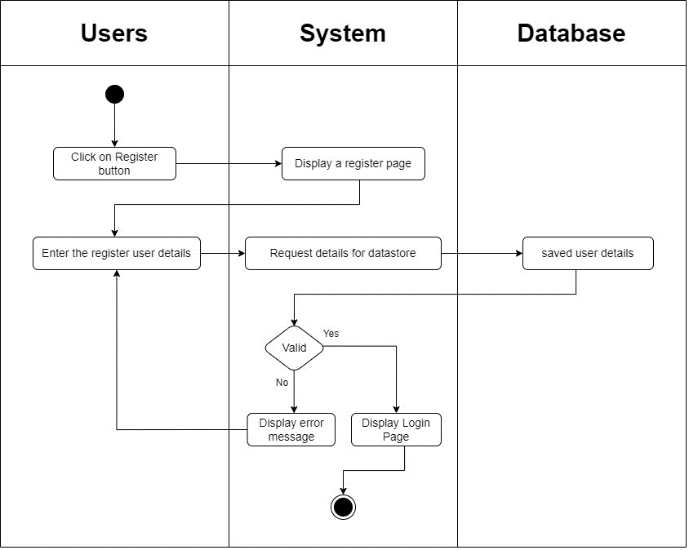

Figure 29: Register system activity diagram

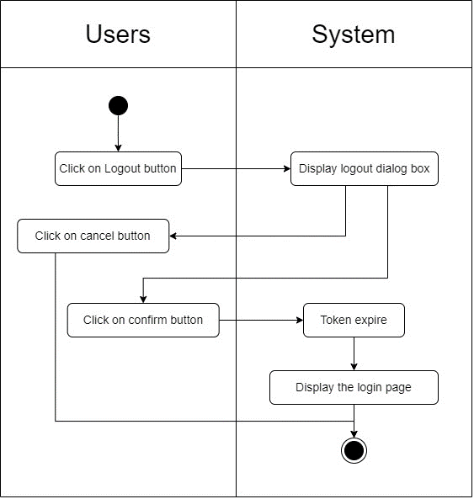

Figure 30: Logout system activity diagram

### 3.6.3. View History Activity

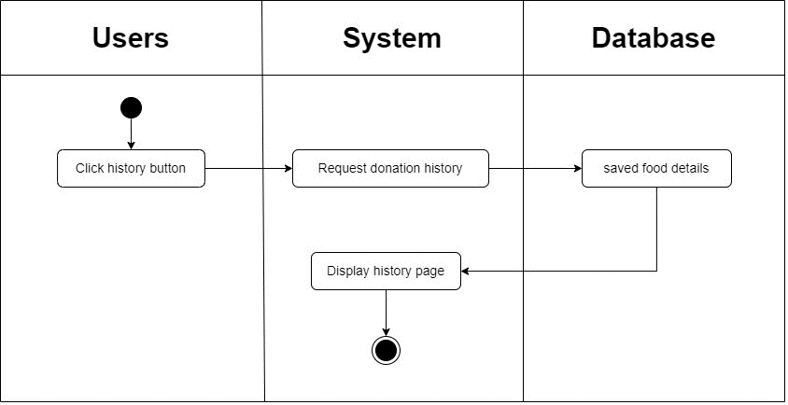

Figure 31: View the history system activity diagram.

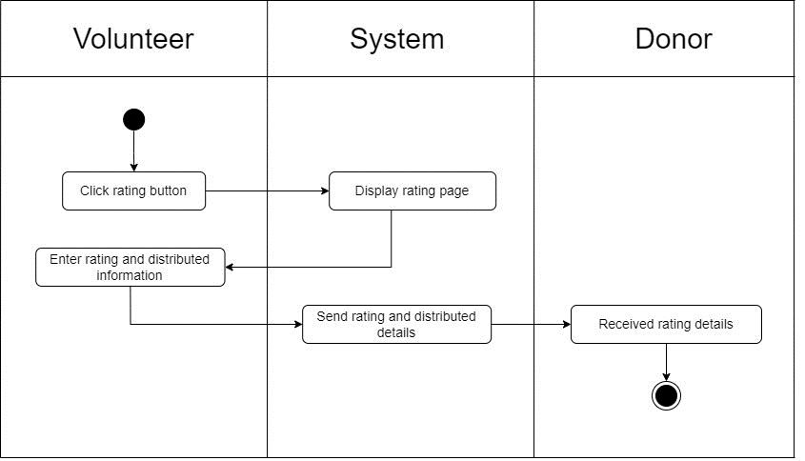

Figure 32: Rating donation system activity diagram

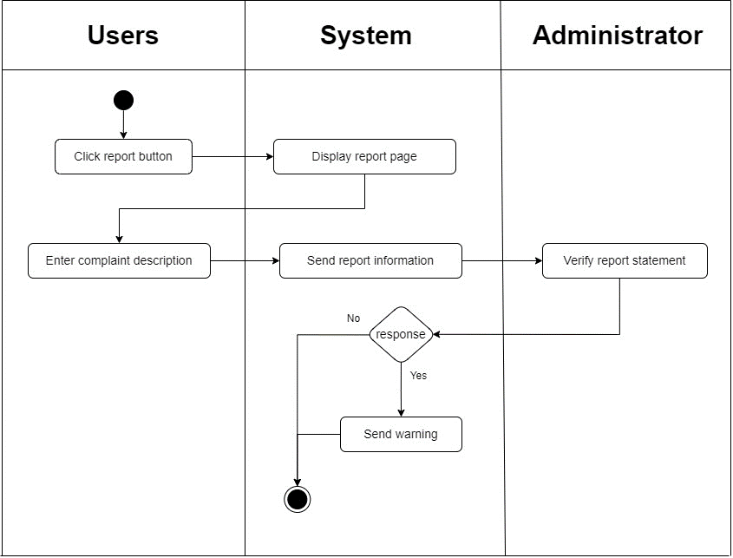

Figure 33: Complaint with admin system activity diagram

# Wireframes

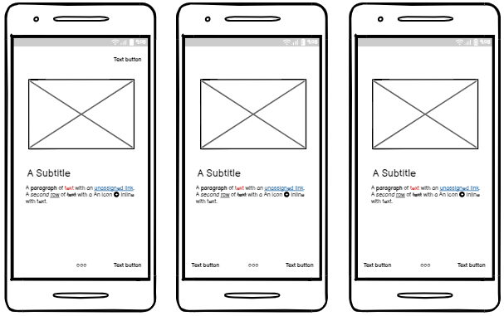

Figure 34: Walkthrough screen mobile UI

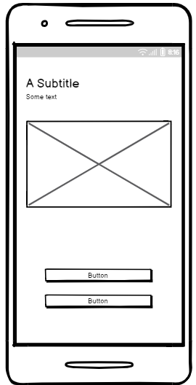

Figure 35: Welcome screen mobile UI

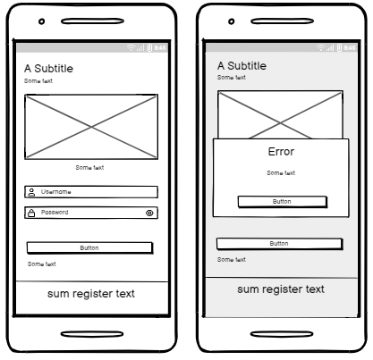

Figure 36: Login screen mobile UI

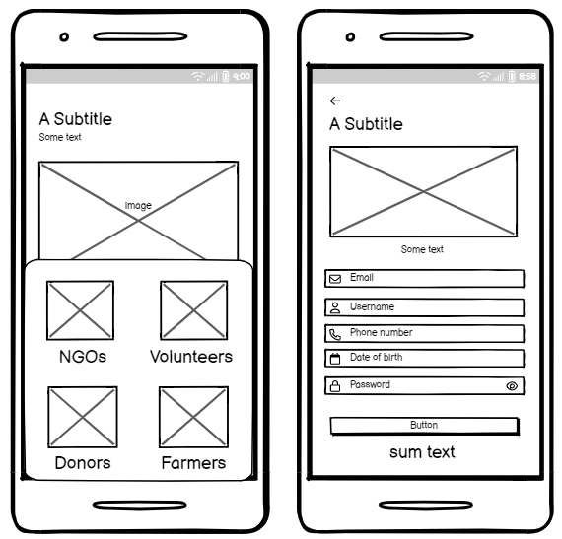

Figure 37: Register screen mobile UI

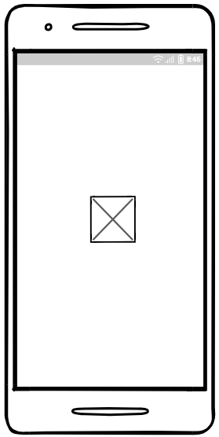

Figure 38: Splash screen mobile UI

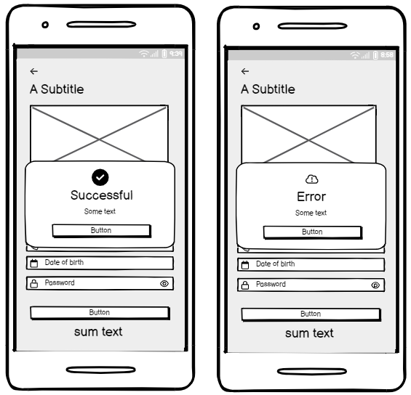

Figure 39: Register response message mobile UI

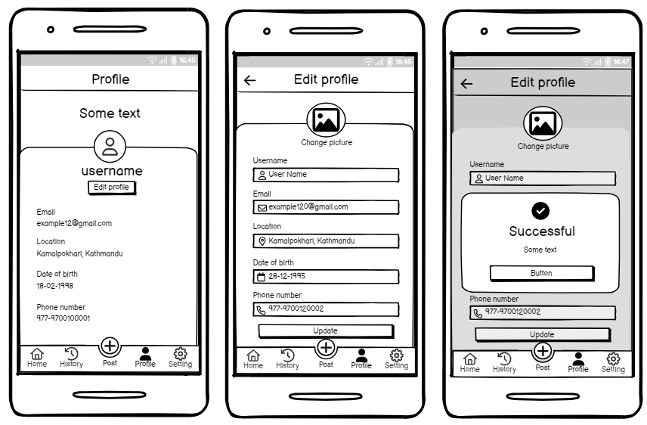

Figure 40: Donor Profile screen mobile UI

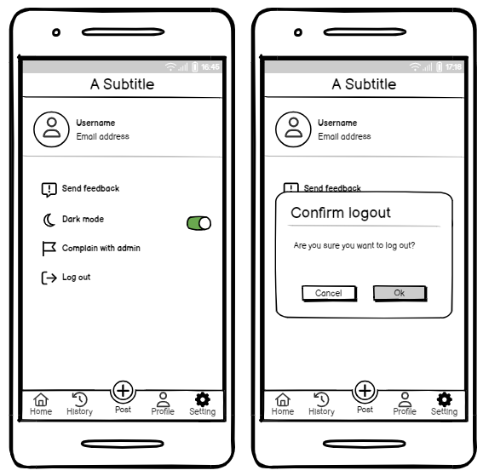

Figure 41: Donor Setting screen mobile UI

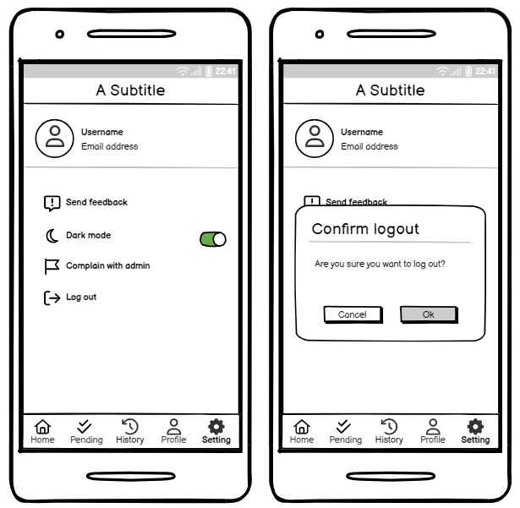

Figure 42: Volunteer Setting screen UI

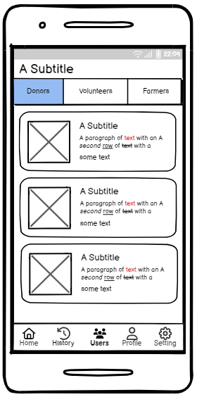

Figure 43: NGO Users screen UI

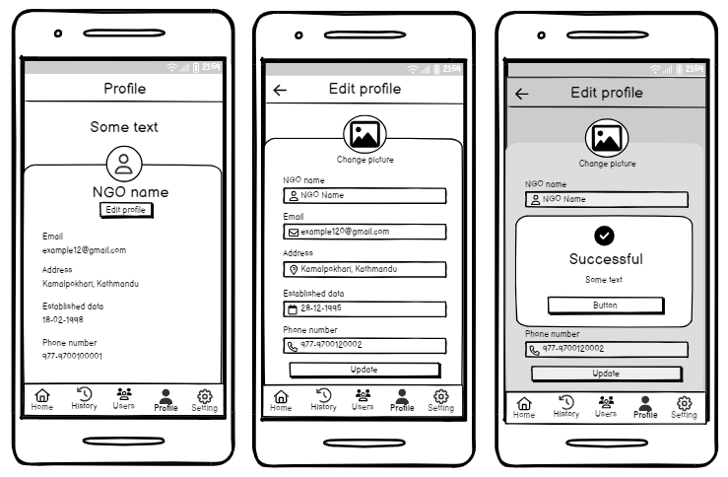

Figure 44: NGO Profile screen UI

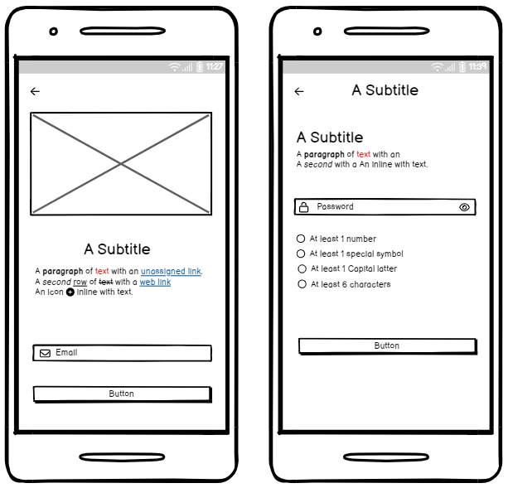

Figure 45: Forgot password screen mobile UI

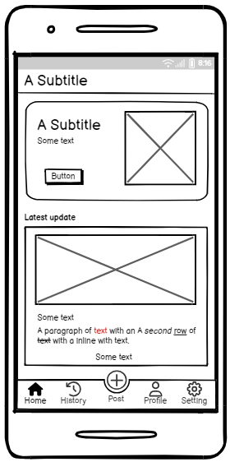

Figure 46: Donor Home screen mobile UI

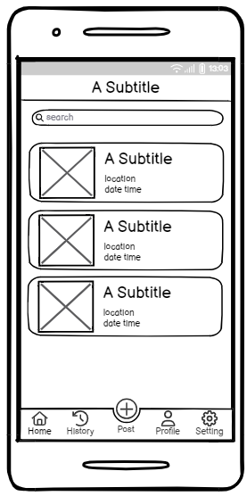

Figure 47: Donor History screen mobile UI

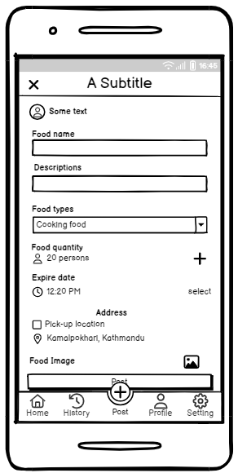

Figure 48: Donor Post/Donation screen mobile UI

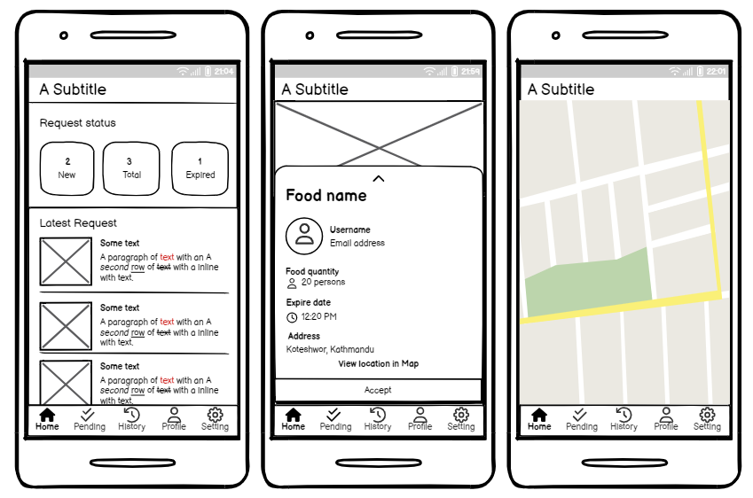

Figure 49: Volunteer Home screen UI

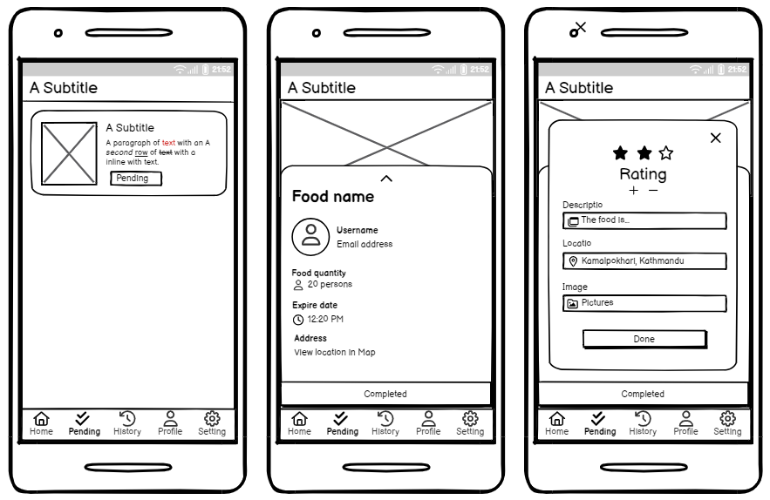

Figure 50: Volunteer Pending screen UI.

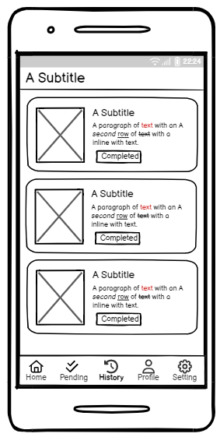

Figure 51: Volunteer History screen

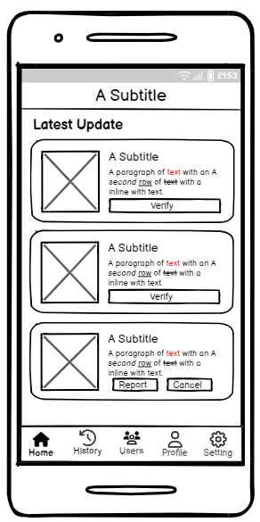

Figure 52: NGO Home screen UI

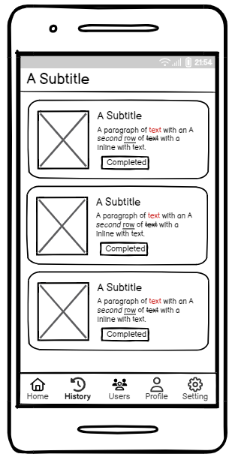

Figure 53: NGO History screen UI

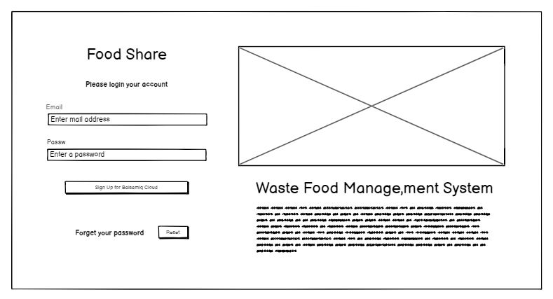

Figure 54: Admin login page web UI

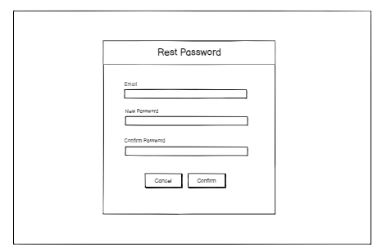

Figure 55: Admin forgot password UI.

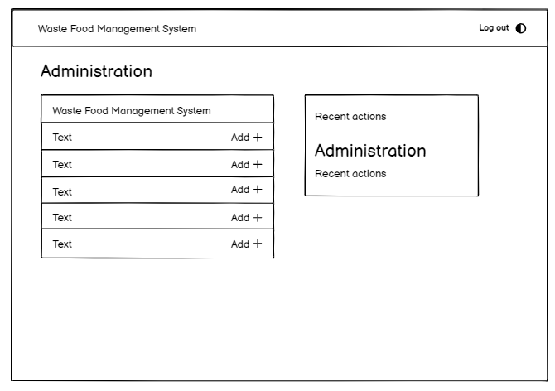

Figure 56: Admin dashboard UI

# ERD

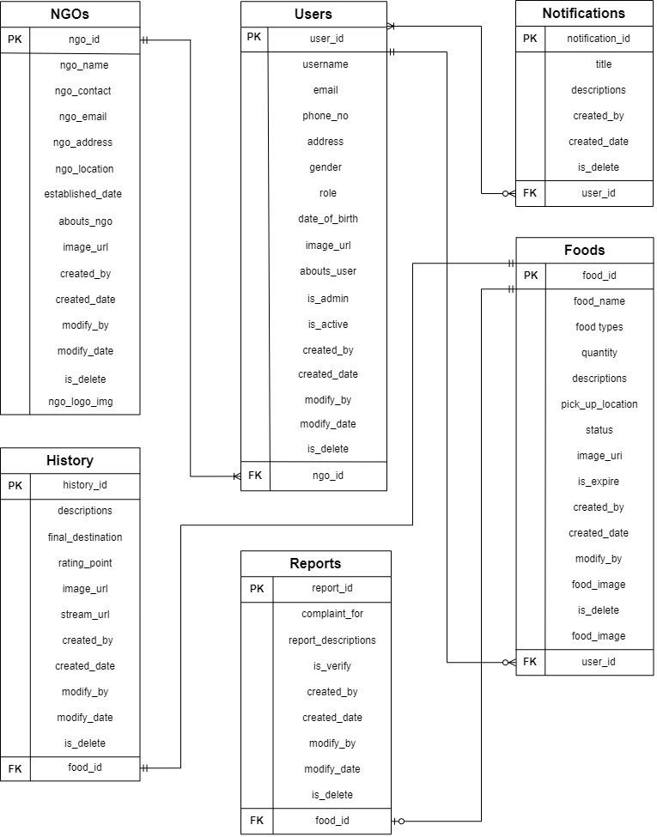

Figure 57: ER-Diagram

# System Architecture Diagram

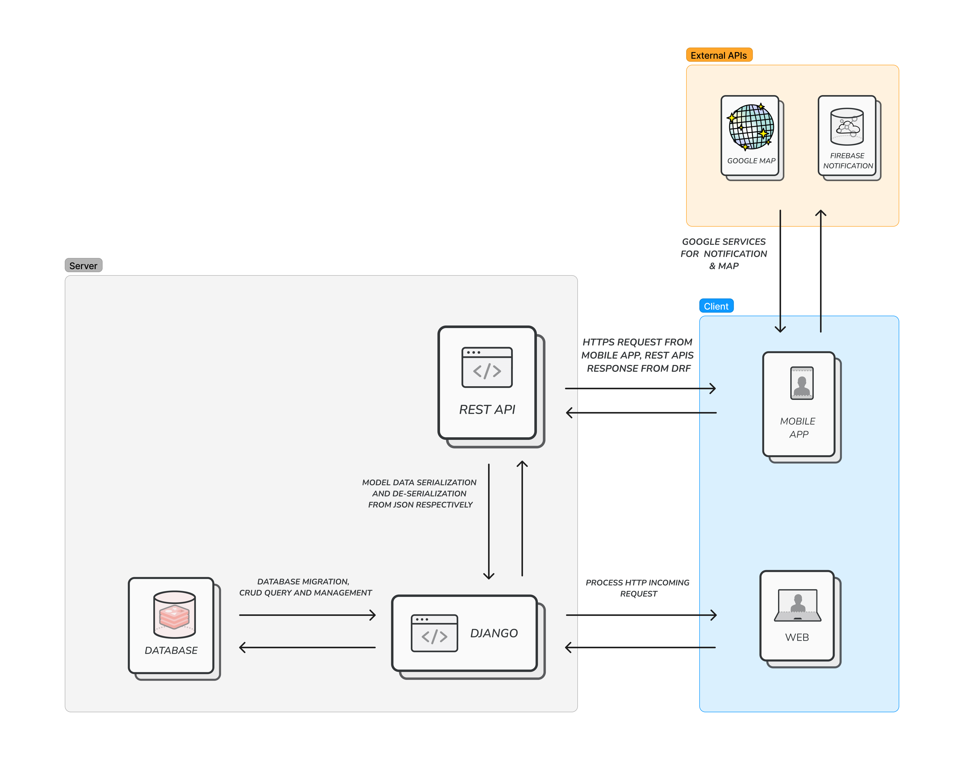

Figure 58: System Architecture Diagram

# Class Diagram

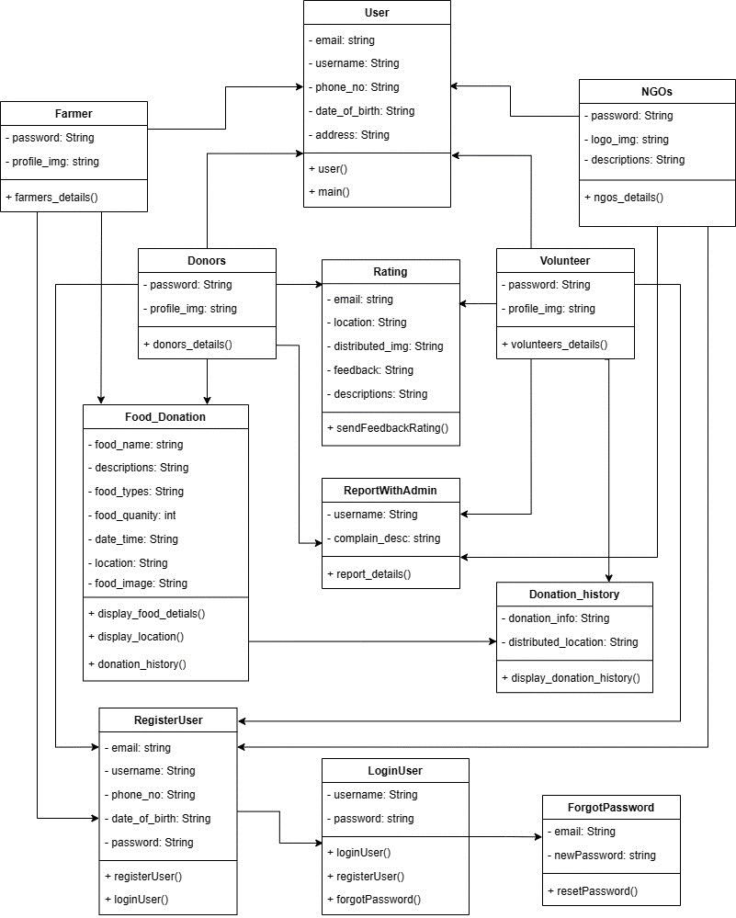

Figure 59: Class diagram of food donation application

# DFD's level 2

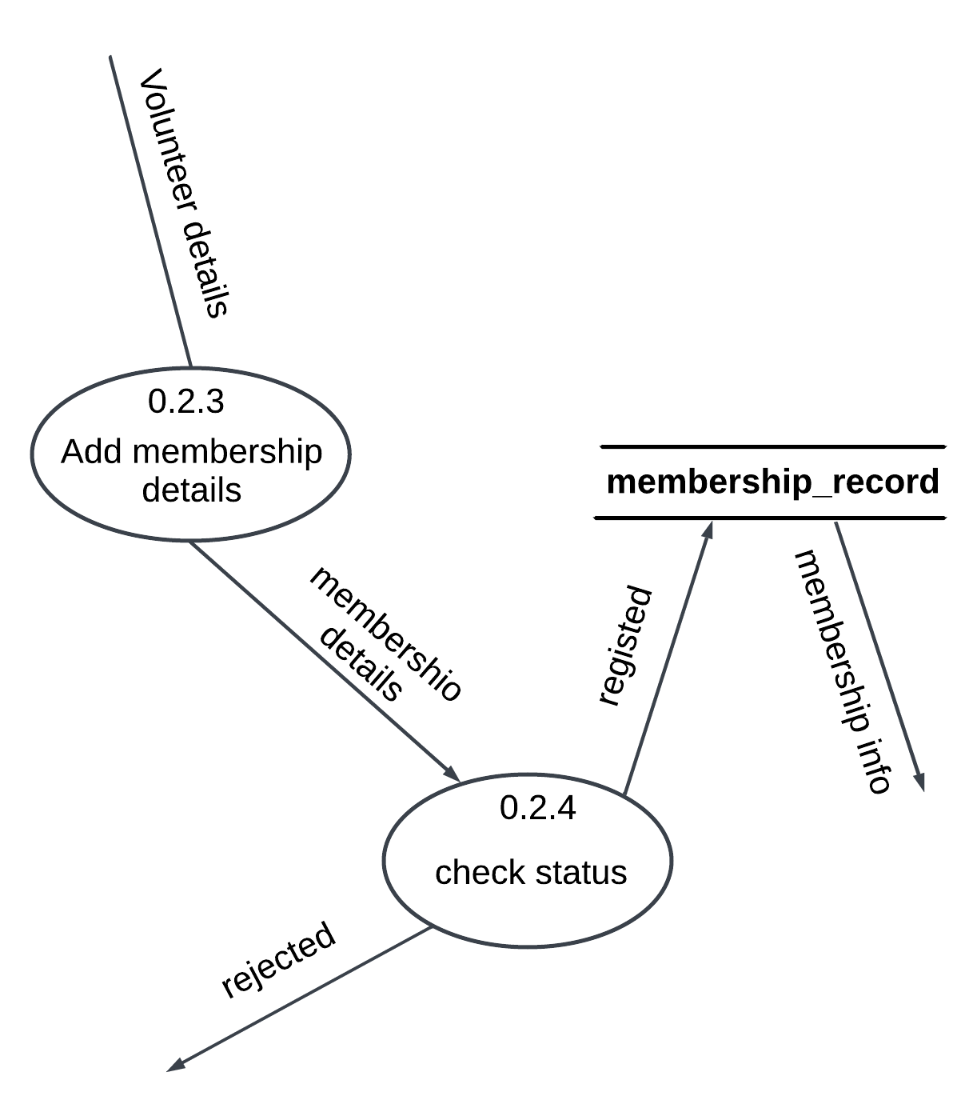

Figure 60: Take membership details DFD Level-2

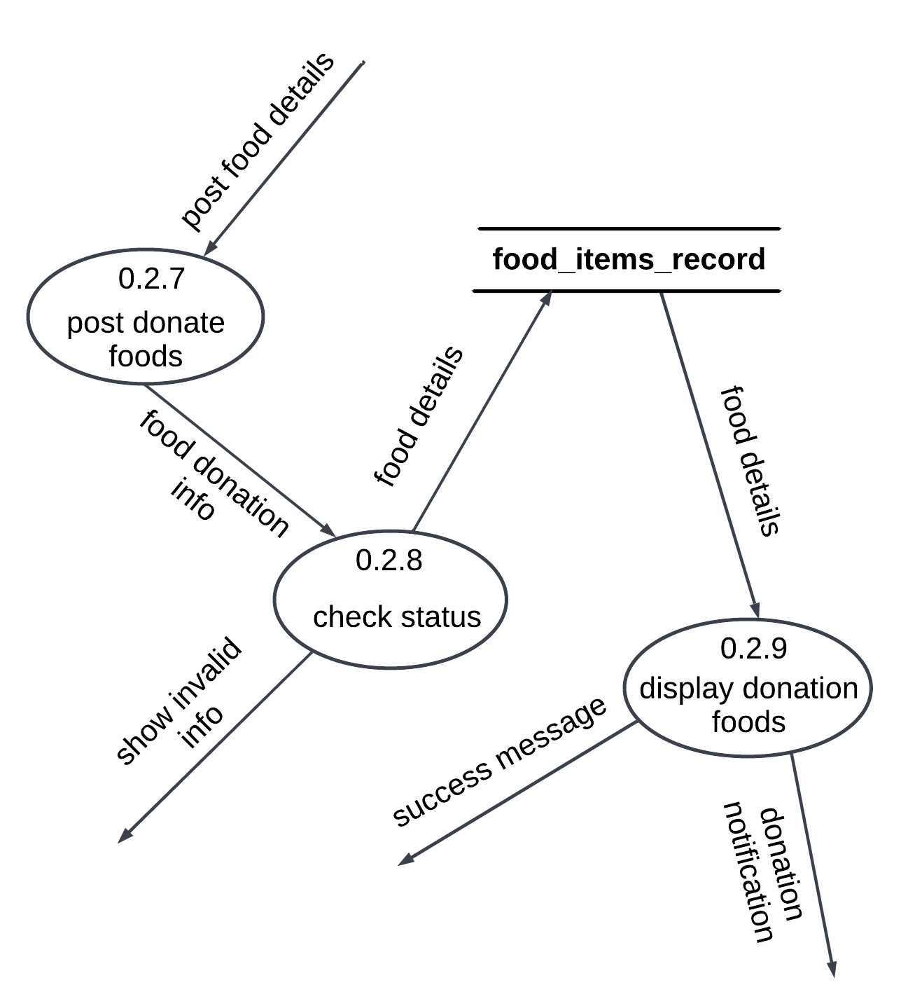

Figure 61: Food donation DFD Level-2

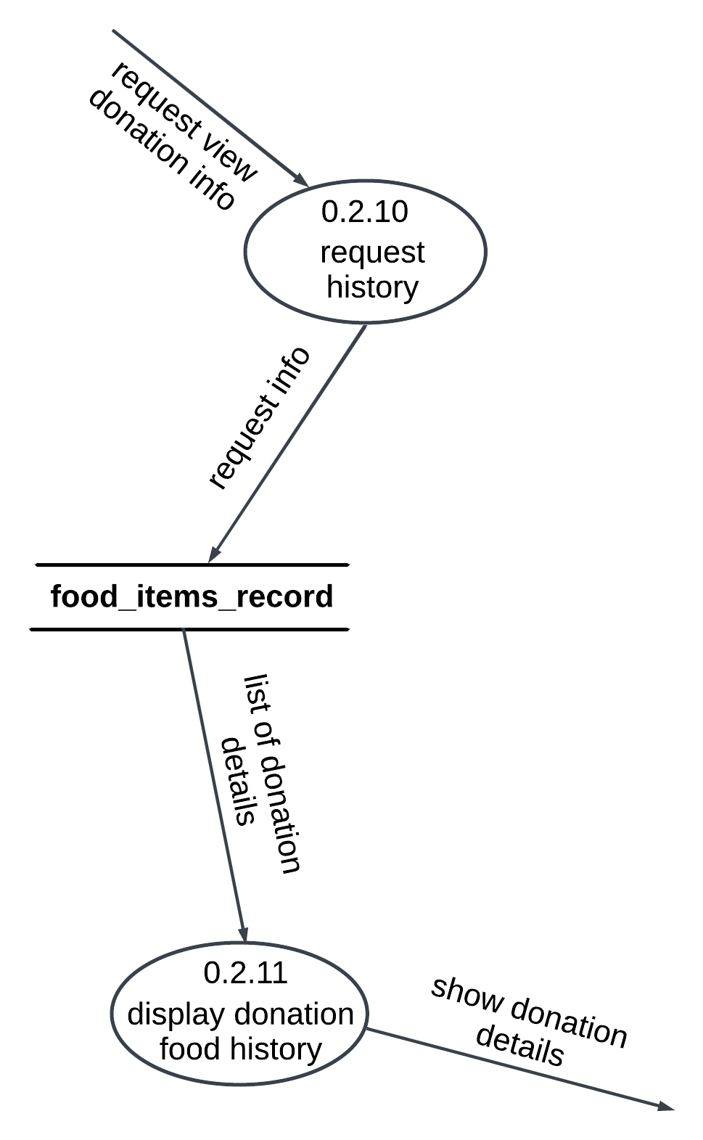

Figure 62: View Donation History DFD Level-2

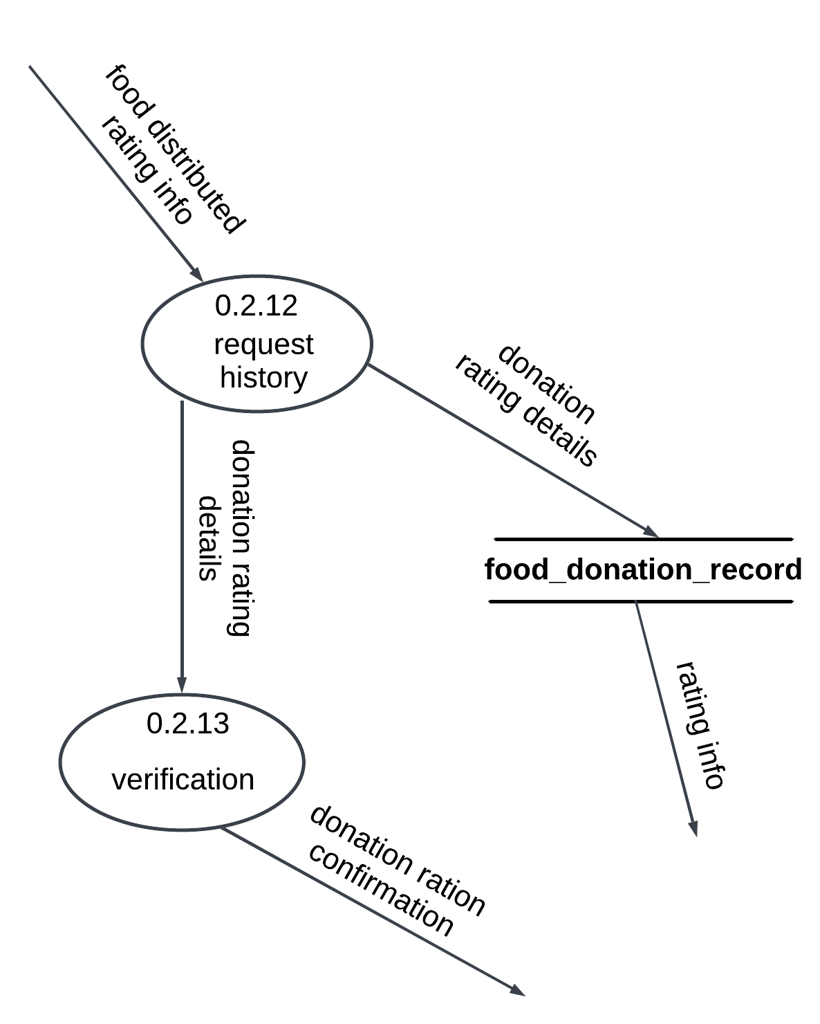

Figure 63: Donation rating DFD Level-2

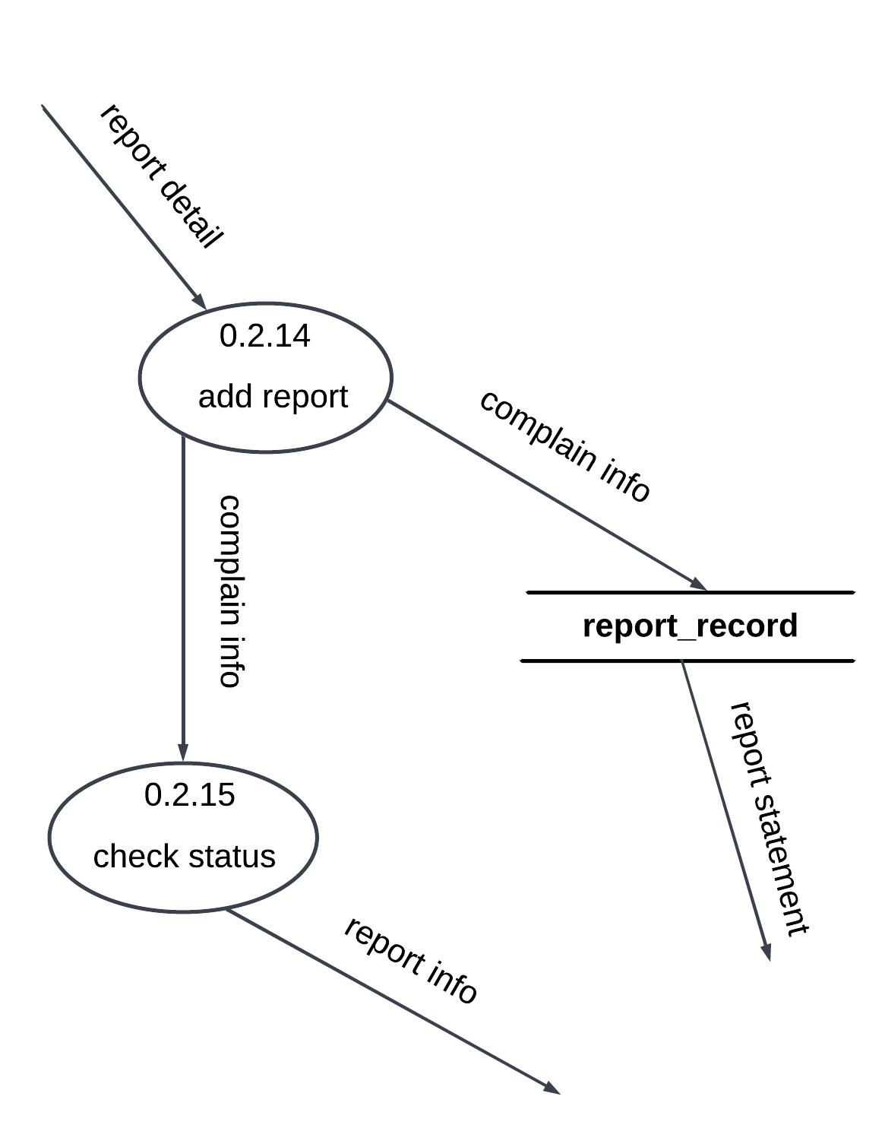

Figure 64: Complaint with admin DFD Level-2

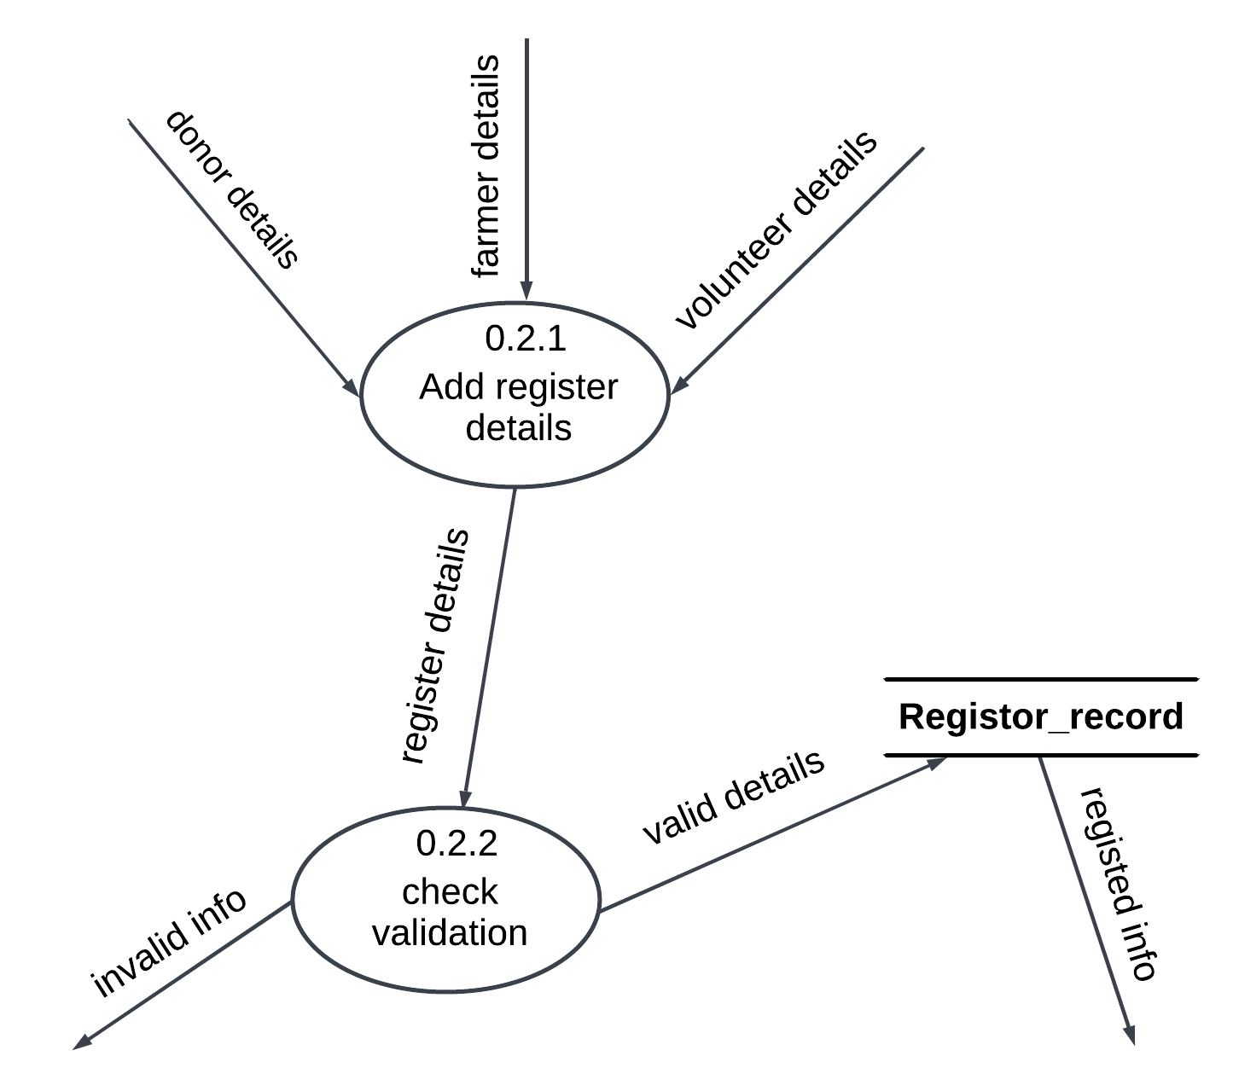

Figure 65: Register details DFD Level-2

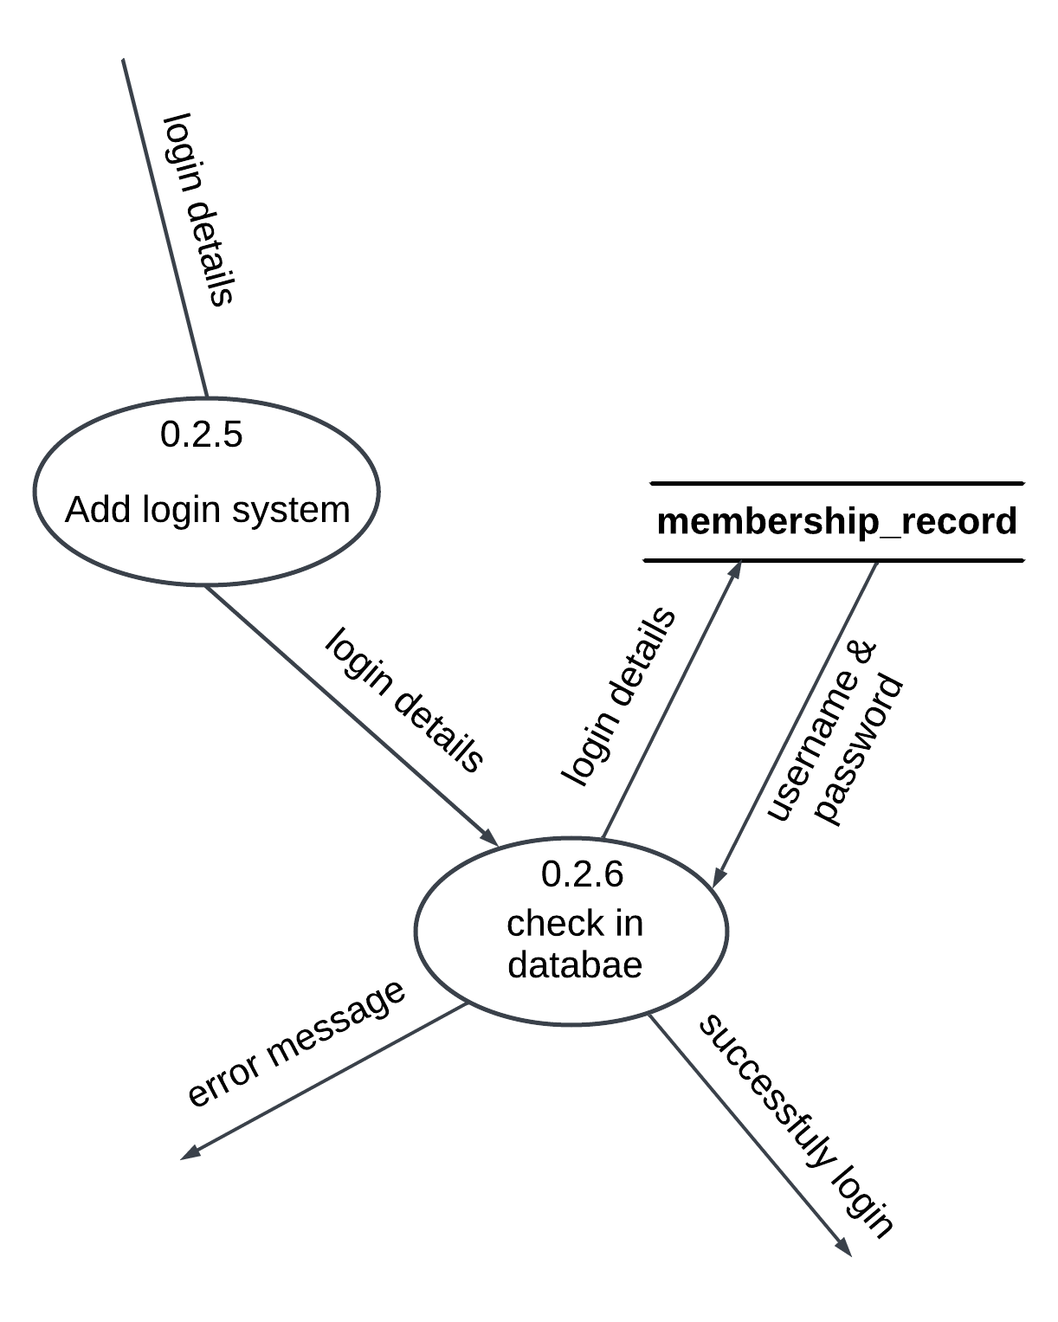

Figure 66: Login details DFD Level-2